PART I: CI/CD With AWS ECS and Docker [100 points]

1) Docker Basics: Create EC2 Instance. Install Docker. Pull centos:centos6. Create index.html with your greeting. Create Dockerfile. Build a Docker image

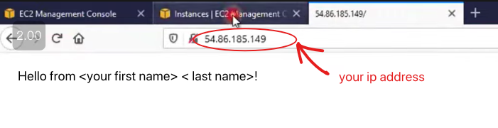

Launch an instance

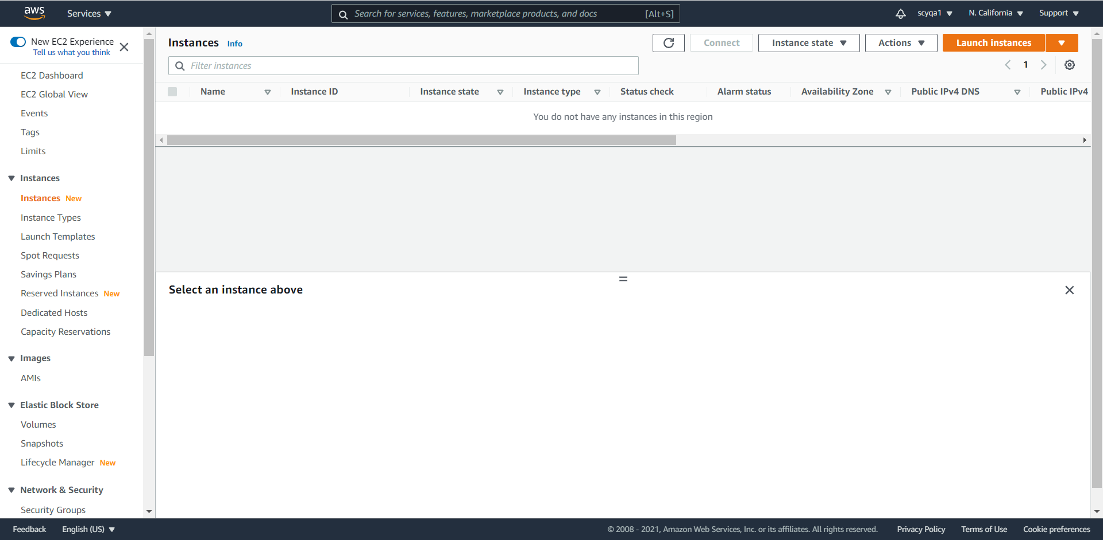

Choose AMI



Choose an instance type

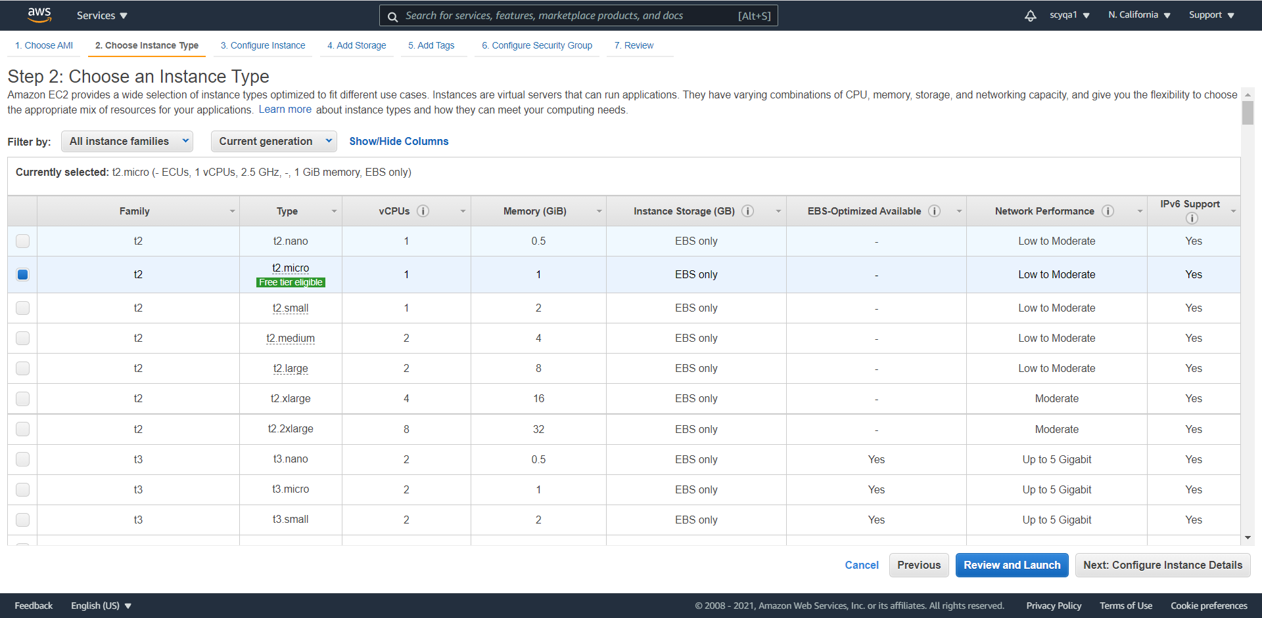

Configure instance details

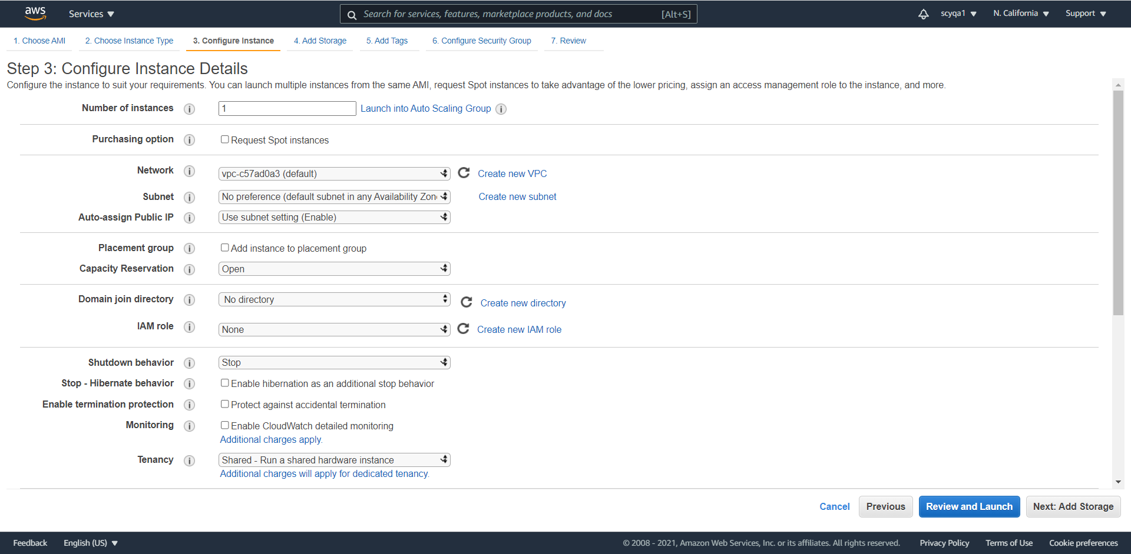

Add storage

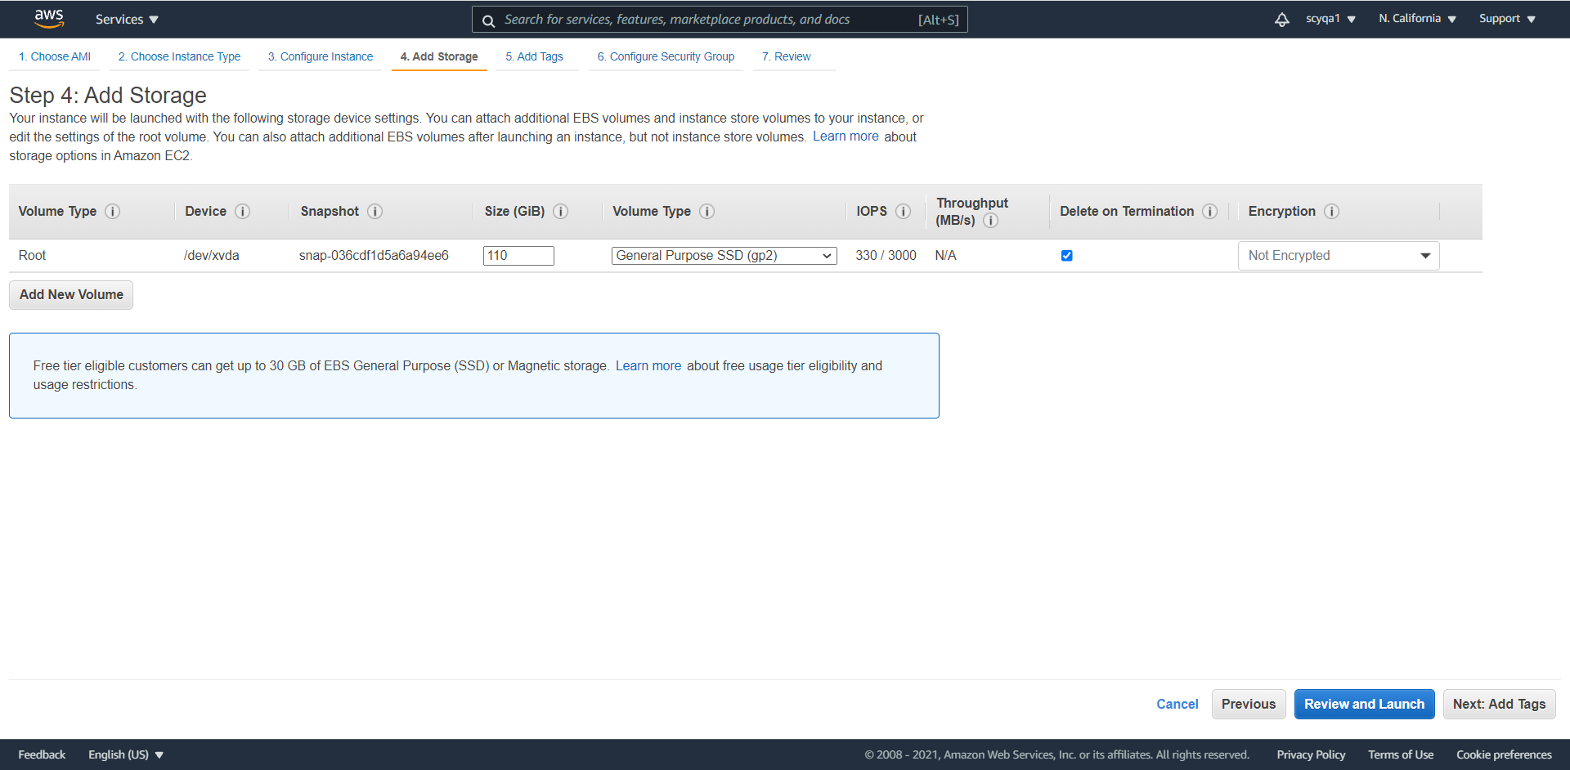

Add tags

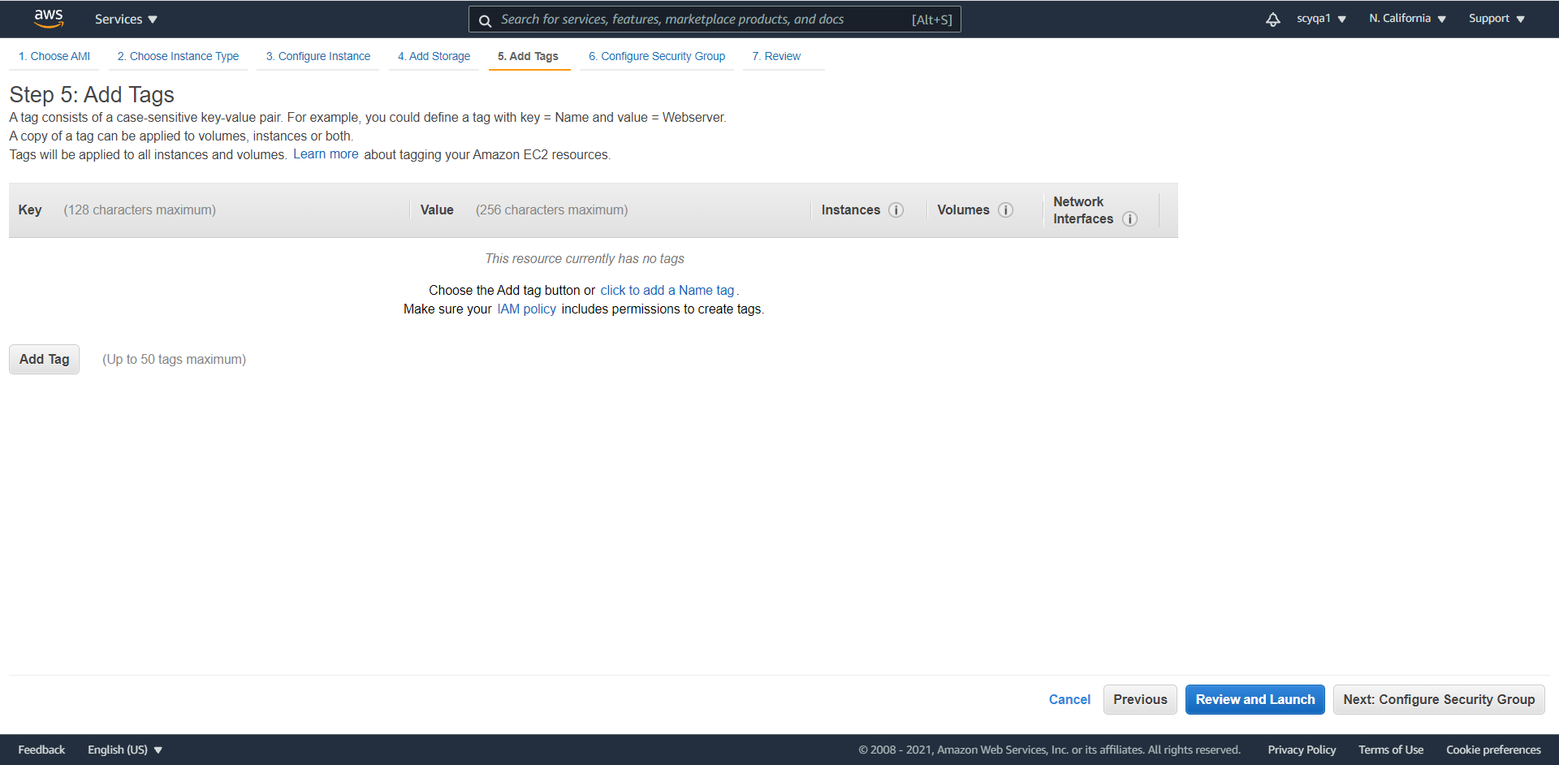

Configure security group

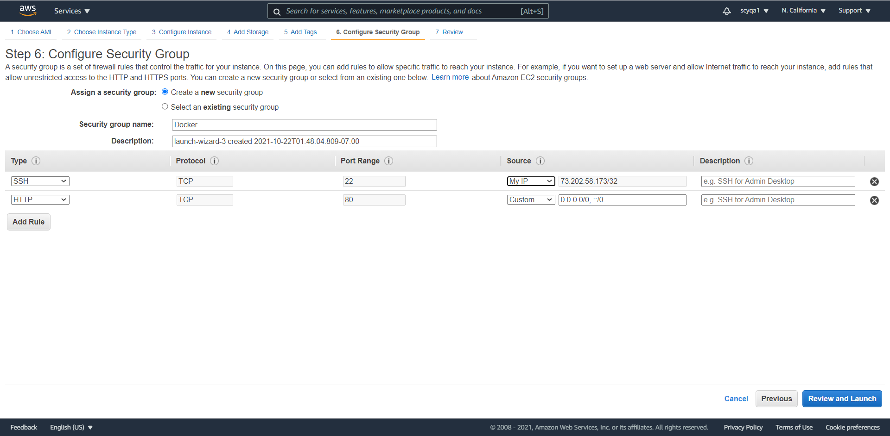

Review instance launch

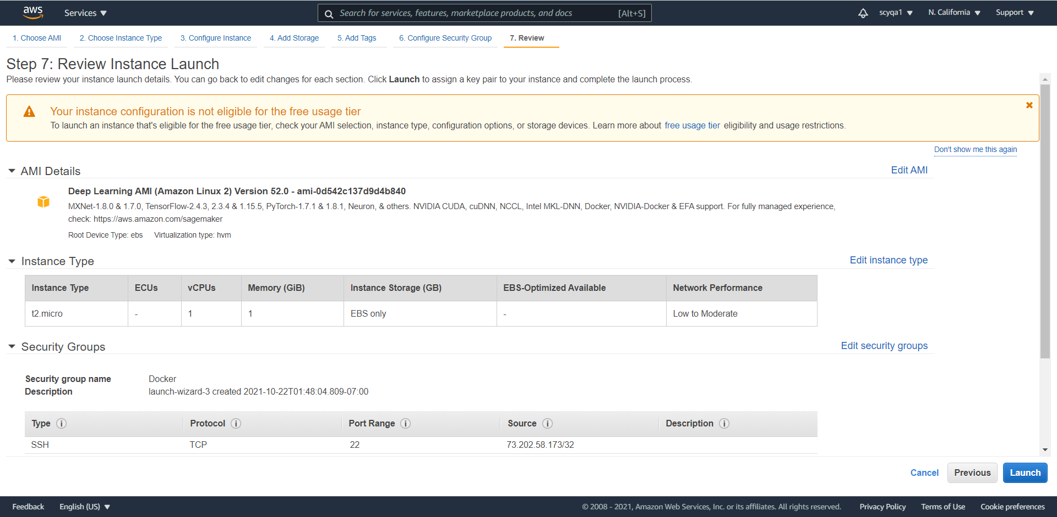

Create a new key pair

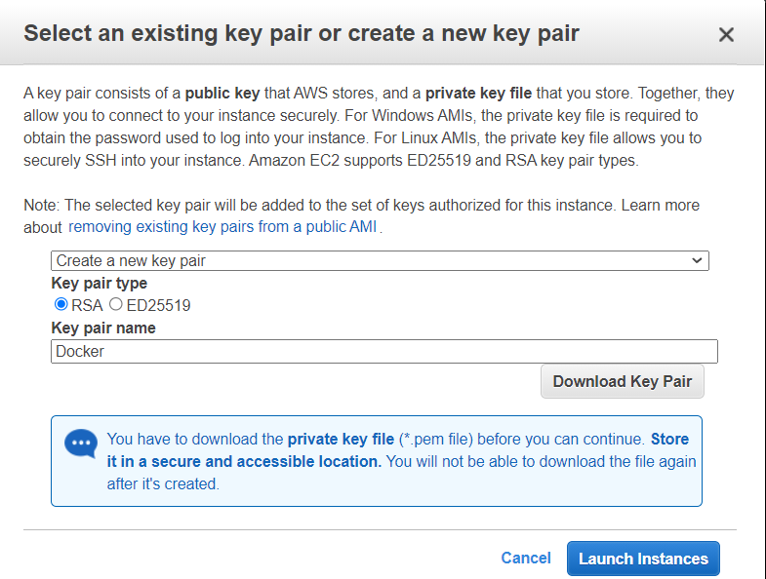

Now, the instance is created

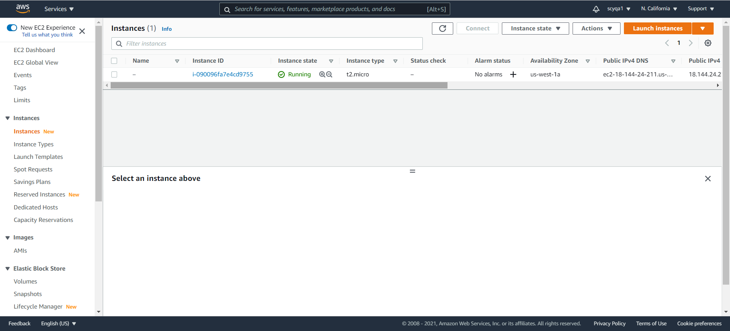

Allocate elastic IP address

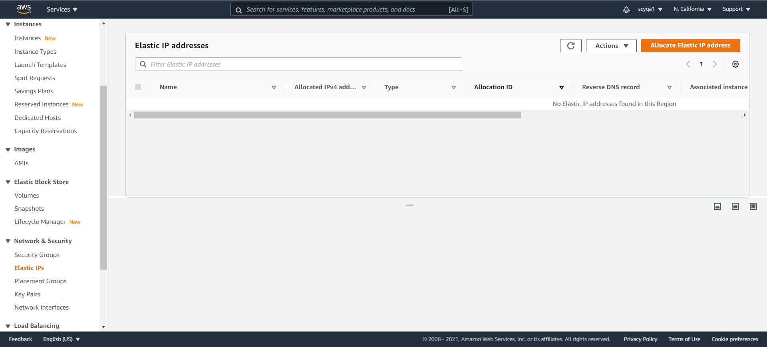

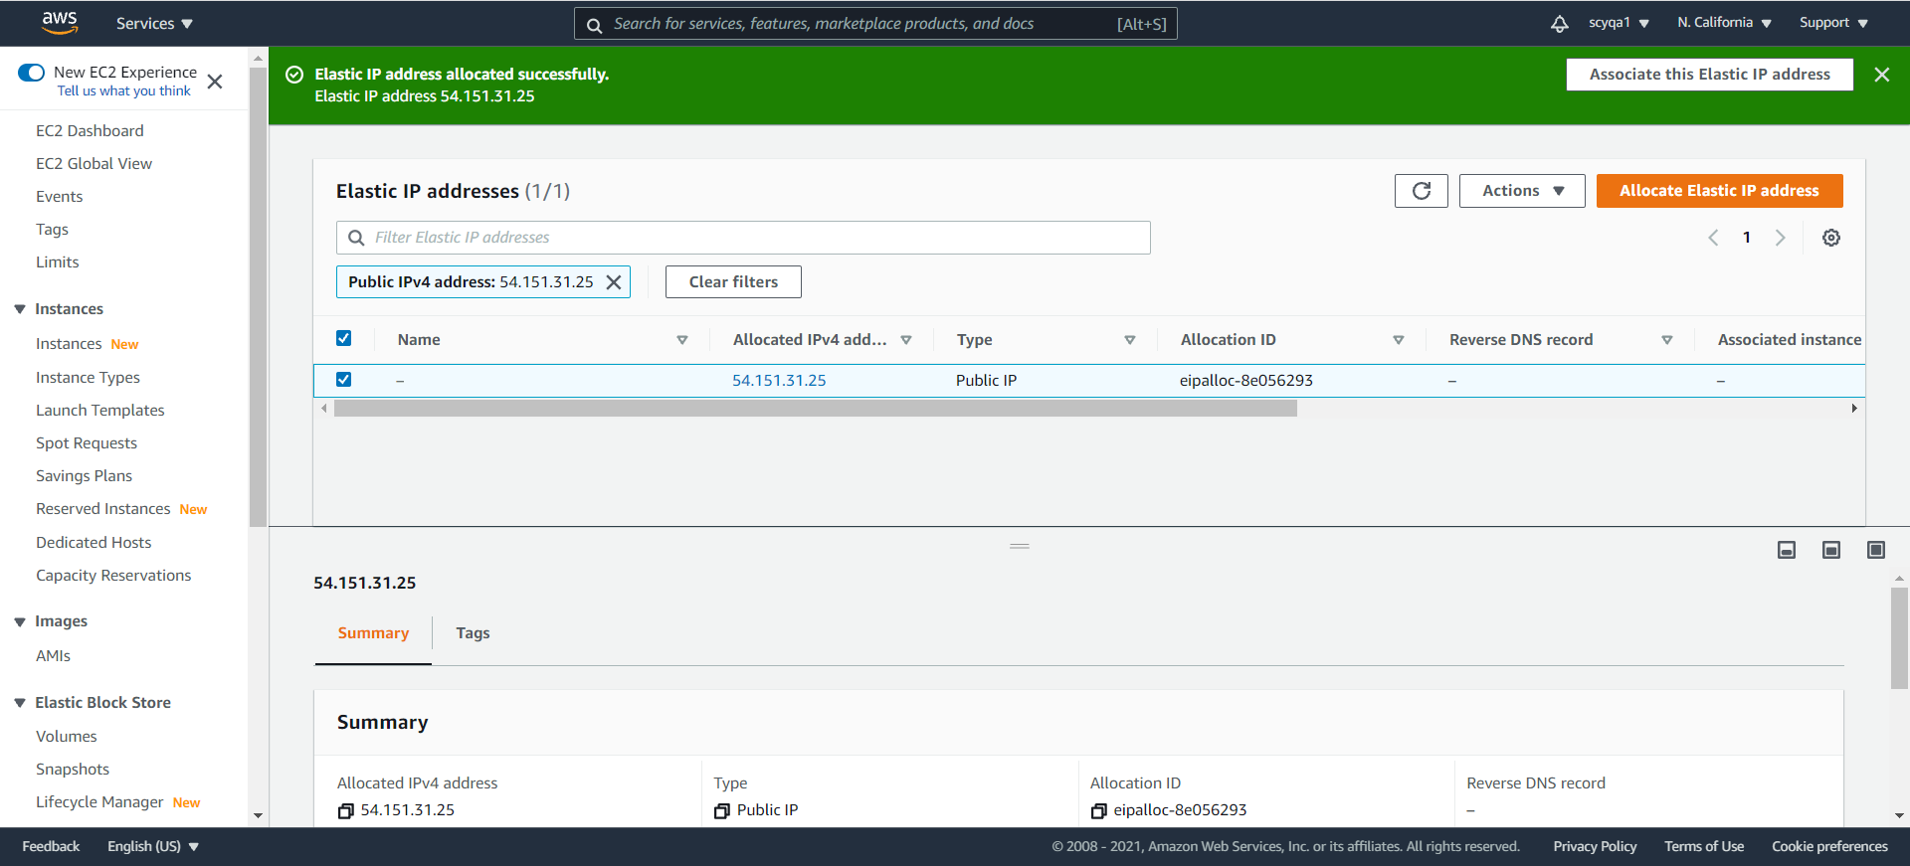

Associate elastic IP address

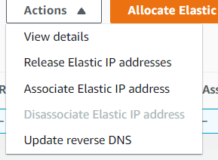

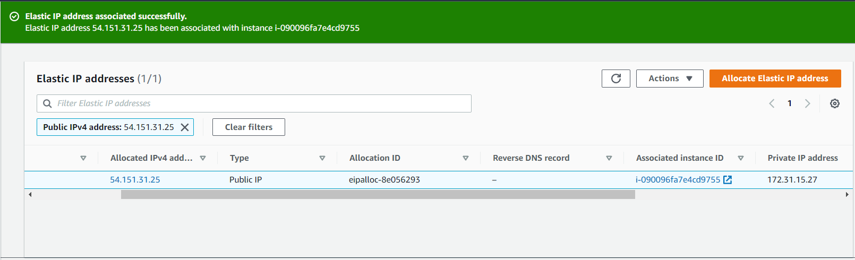

SSH connection to EC2

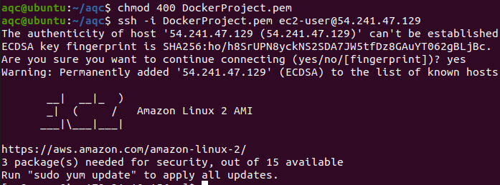

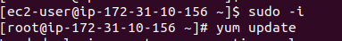

Install Docker





Pull centos:centos6



Docker images

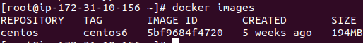

Docker run



Install httpd



Create index.html with my greeting

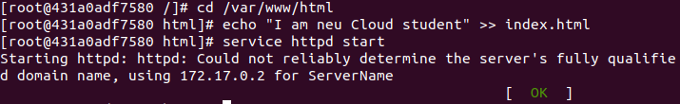

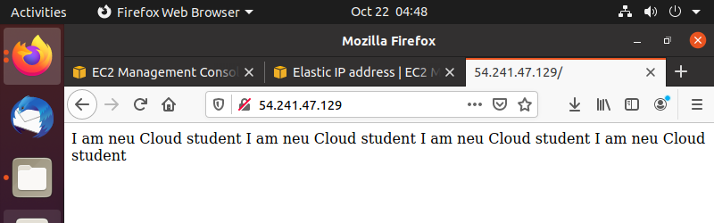

Create Dockerfile.

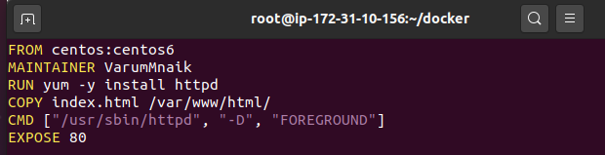

2) [17:57] AWS ECR(Elastics Container Registry) Creation: Create AWS ECR. Login to ECR. Tag existing image as AWS ECR repo. Push the image into the ECR

Create ECR

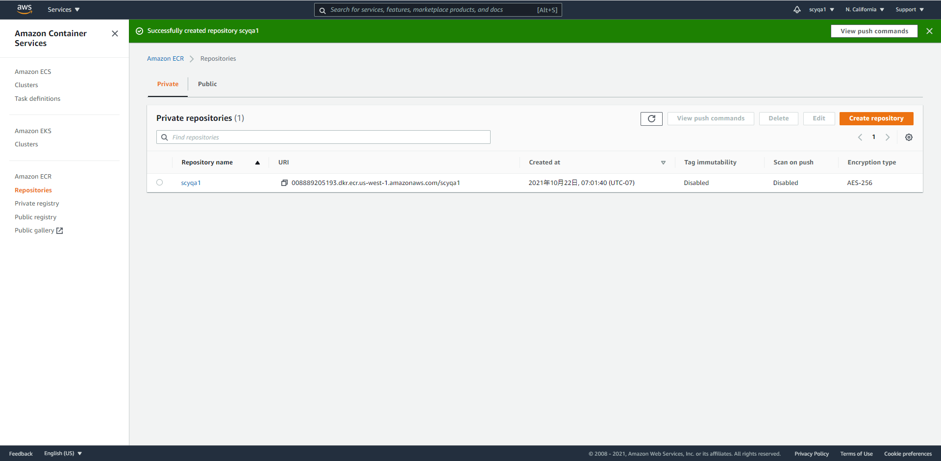

Create a role

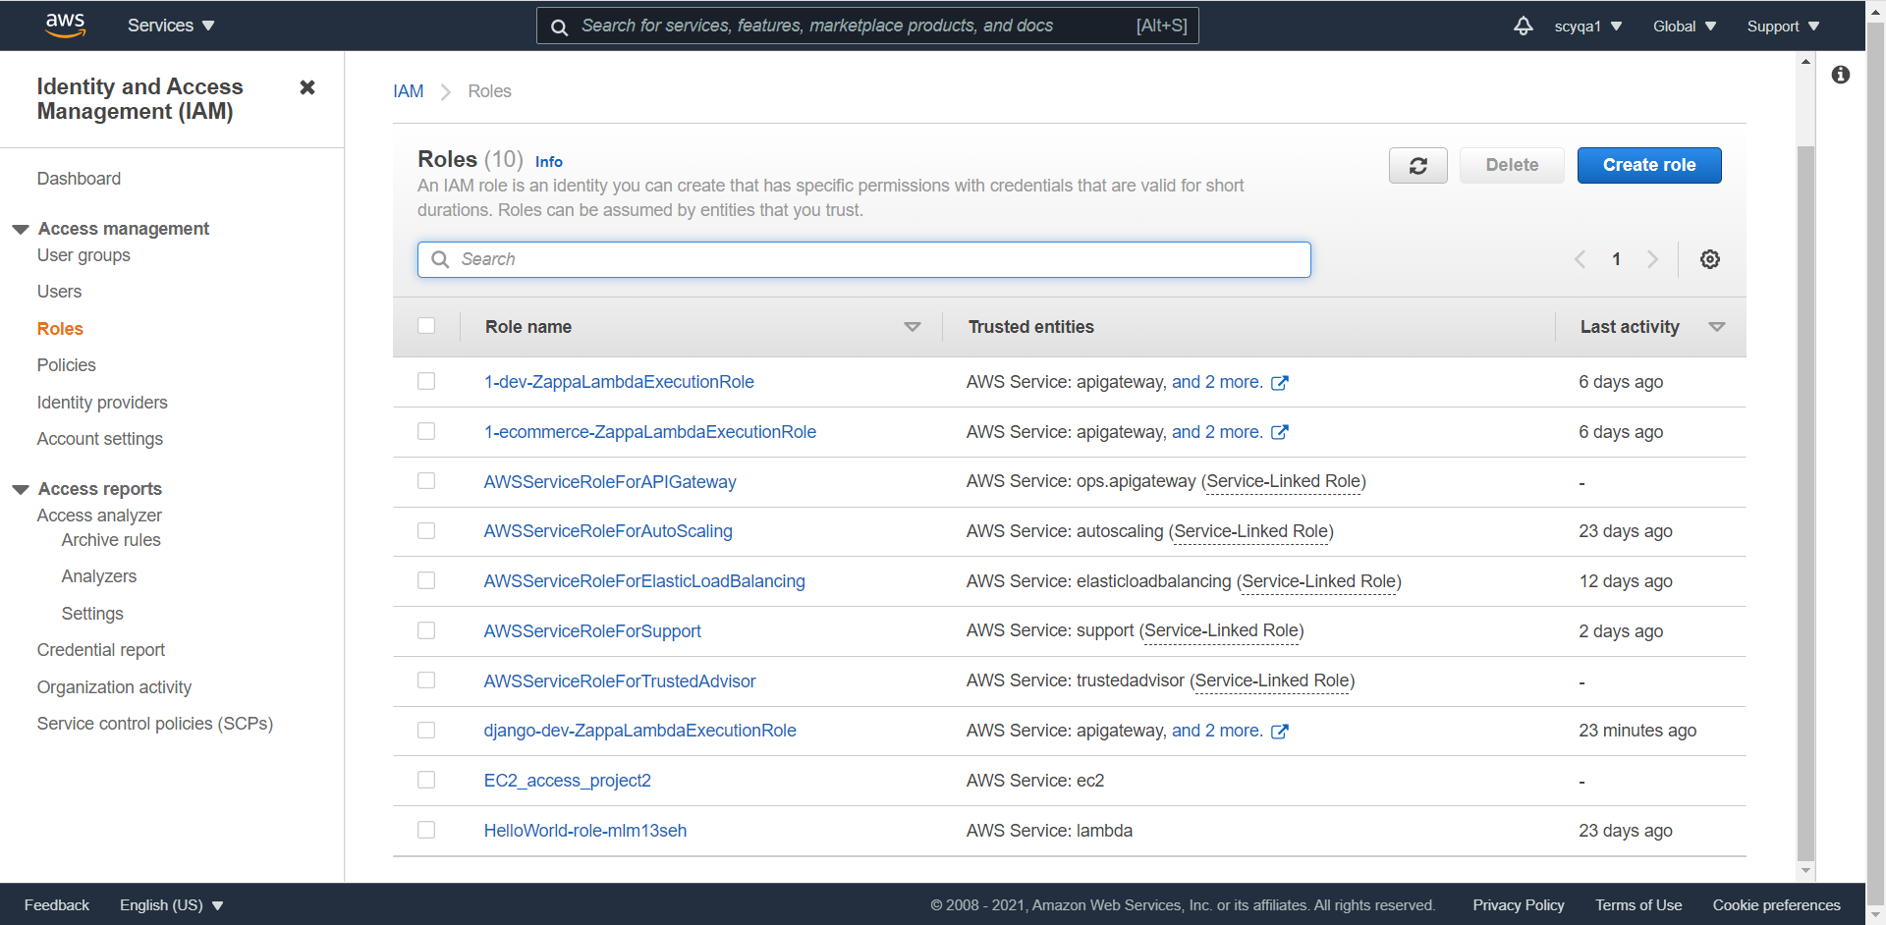

Modify EC2’s IAM role

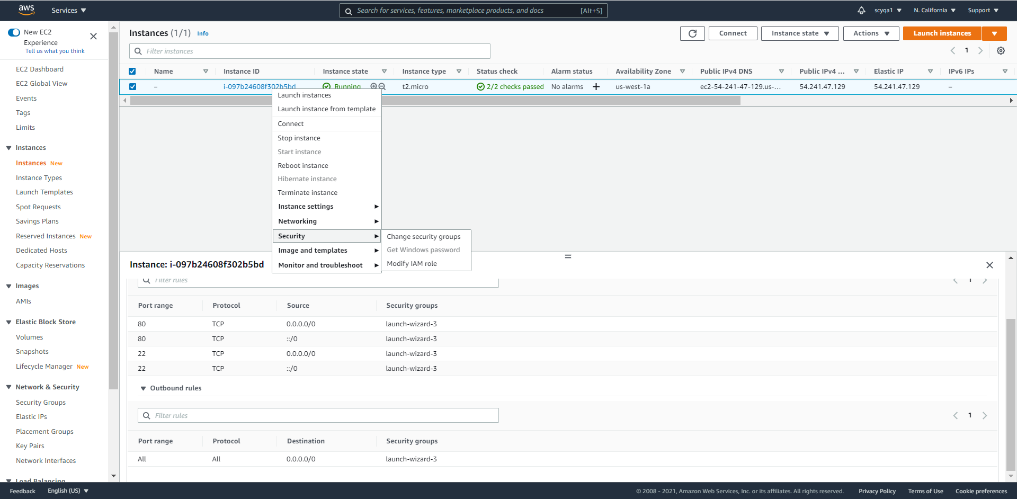

Retrieve an authentication token and authenticate the Docker client to registry using the AWS CLI:

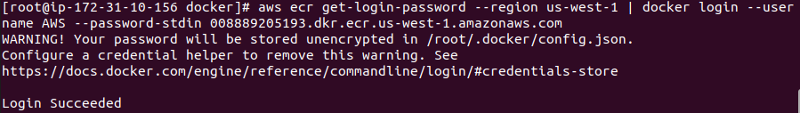

After the build completes, tag the image



push the image to newly created AWS repository

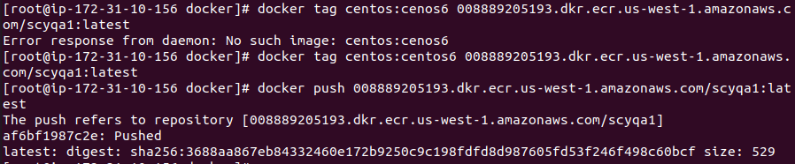

3) Create ALB(Application Load Balancer): Create Target group. Create ALB

Create target group

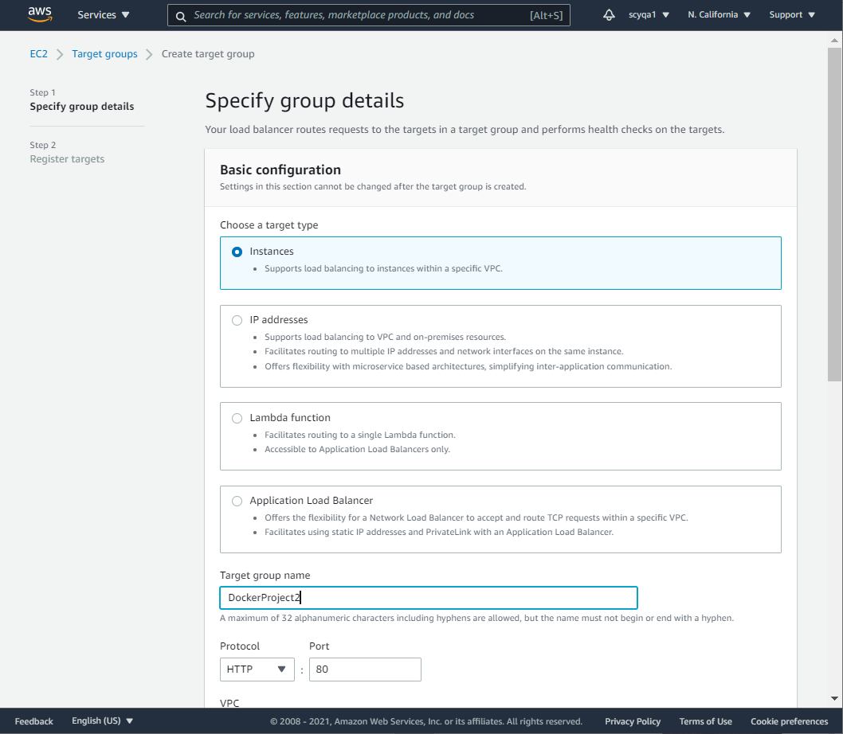

Create application load balancer

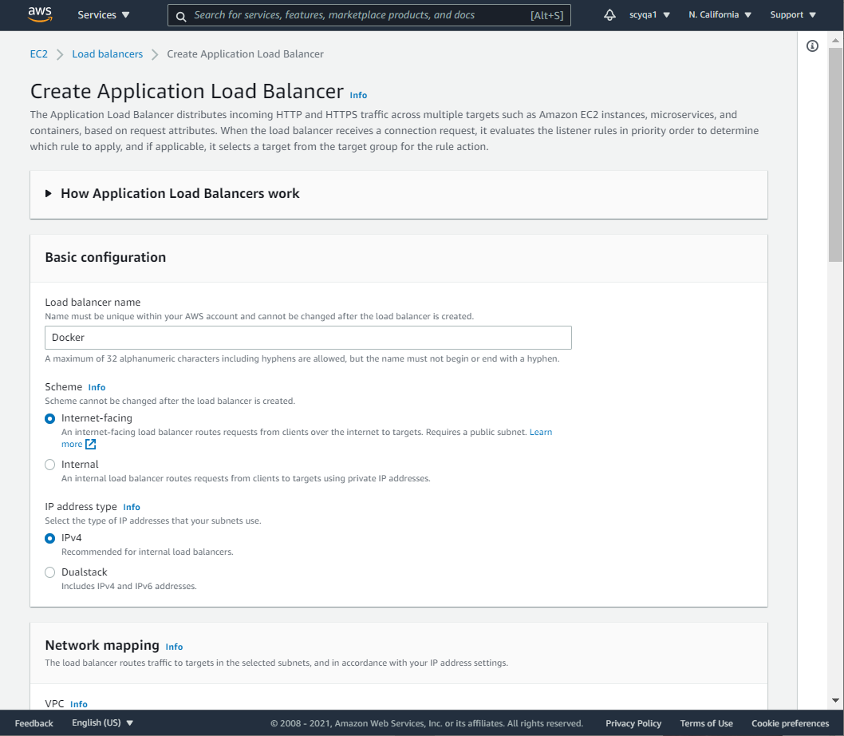

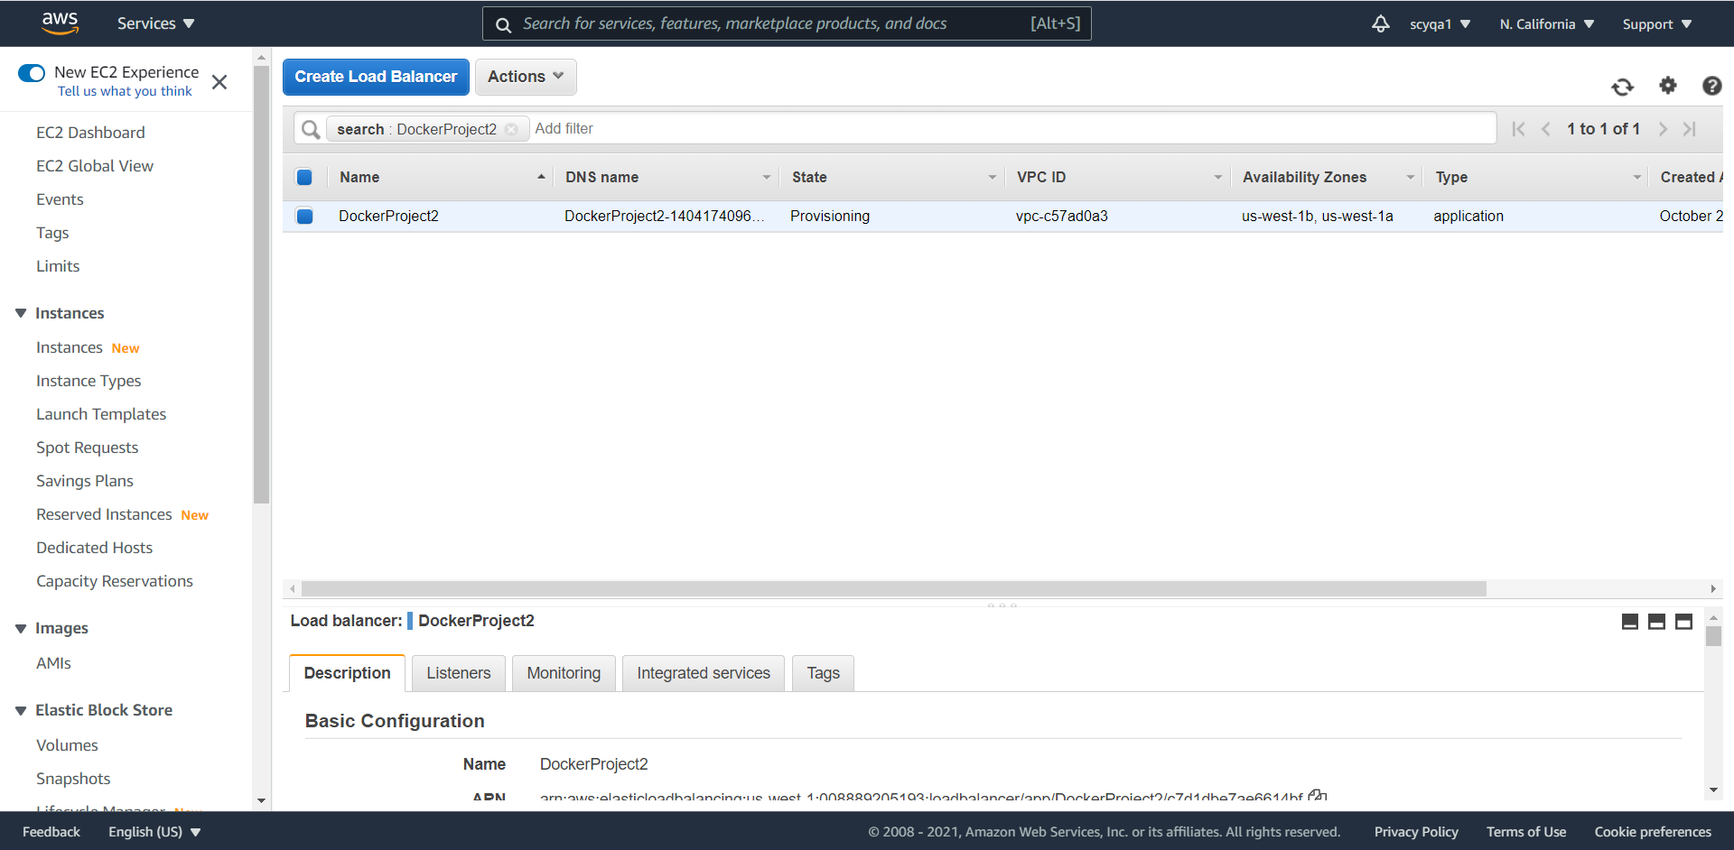

4) Create an AWS ECS(Elastics Container Service) Cluster: Create a Task with Fargate Computability. Create a Fargate Cluster. Create a Service with ALB enabled. Test ALB DNS, whether your site is running or not. Add your container with auto-config CloudWatch Logs

Create new Task definition

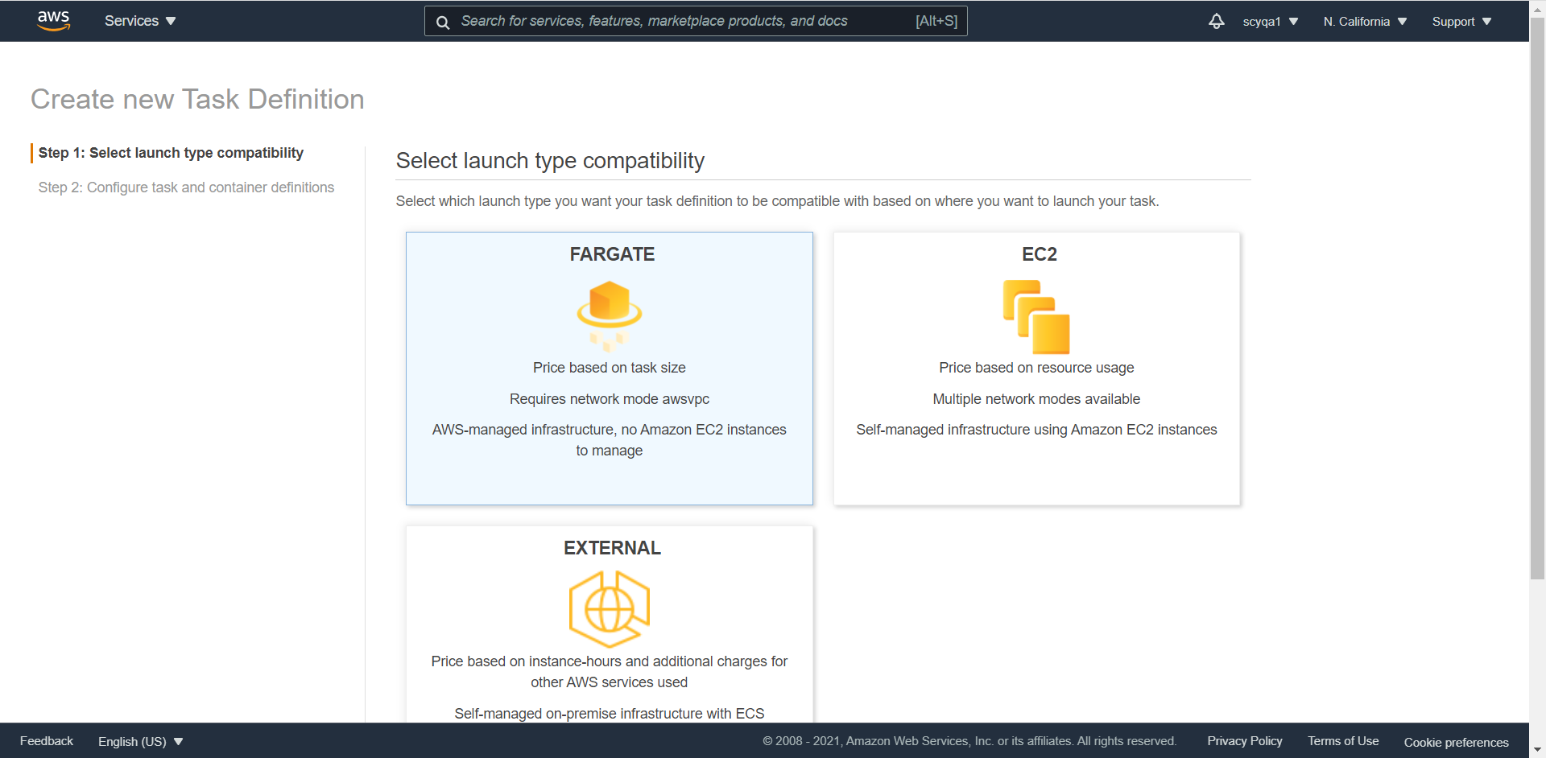

Add container

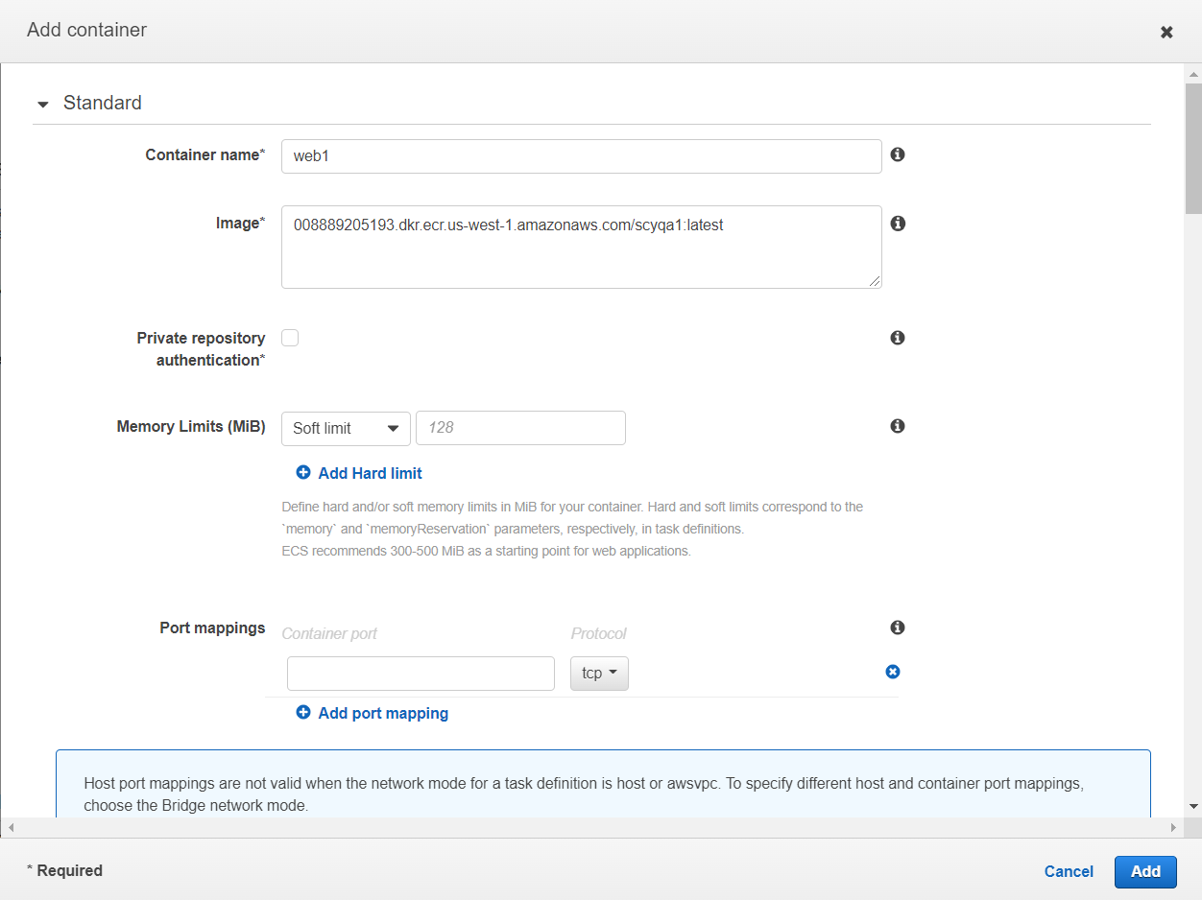

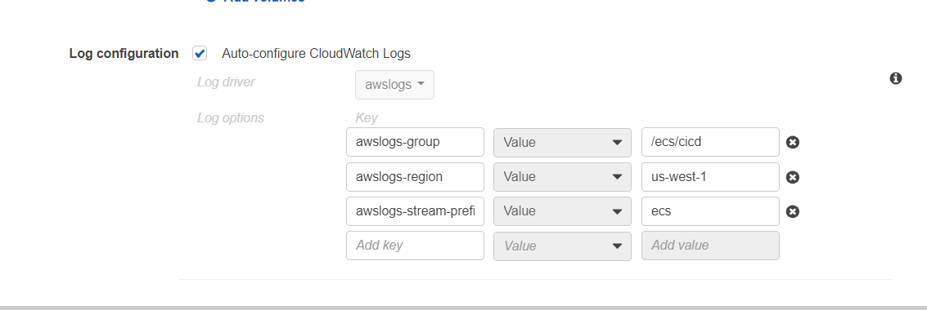

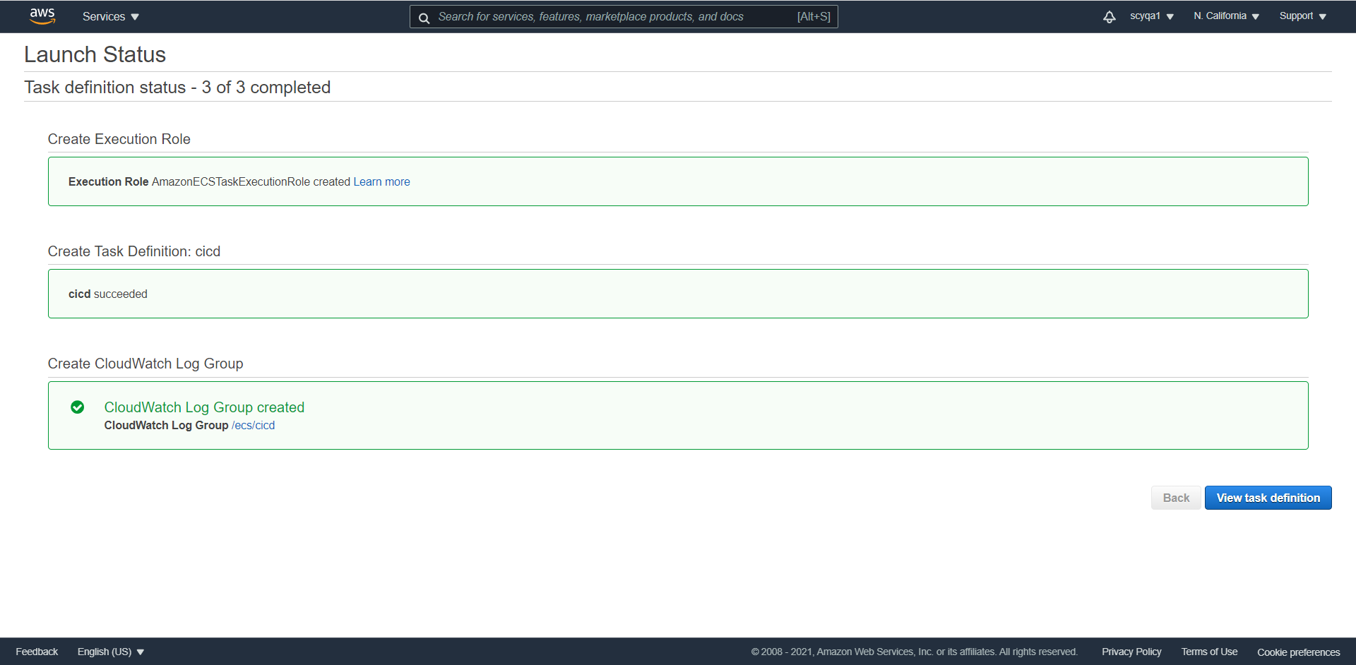

Create cluster

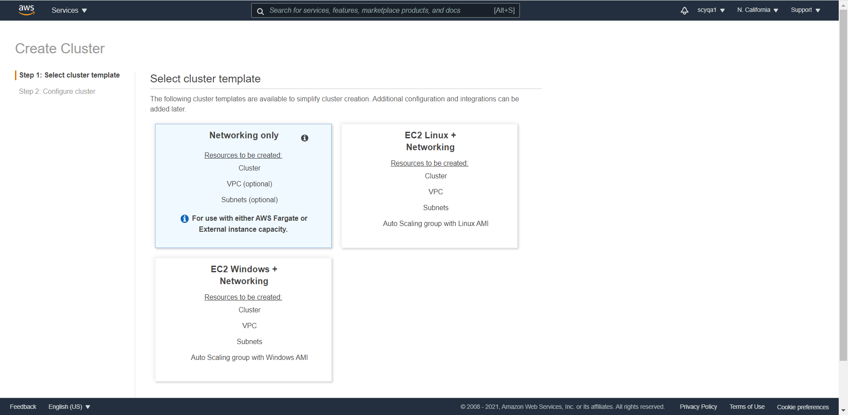

Create service

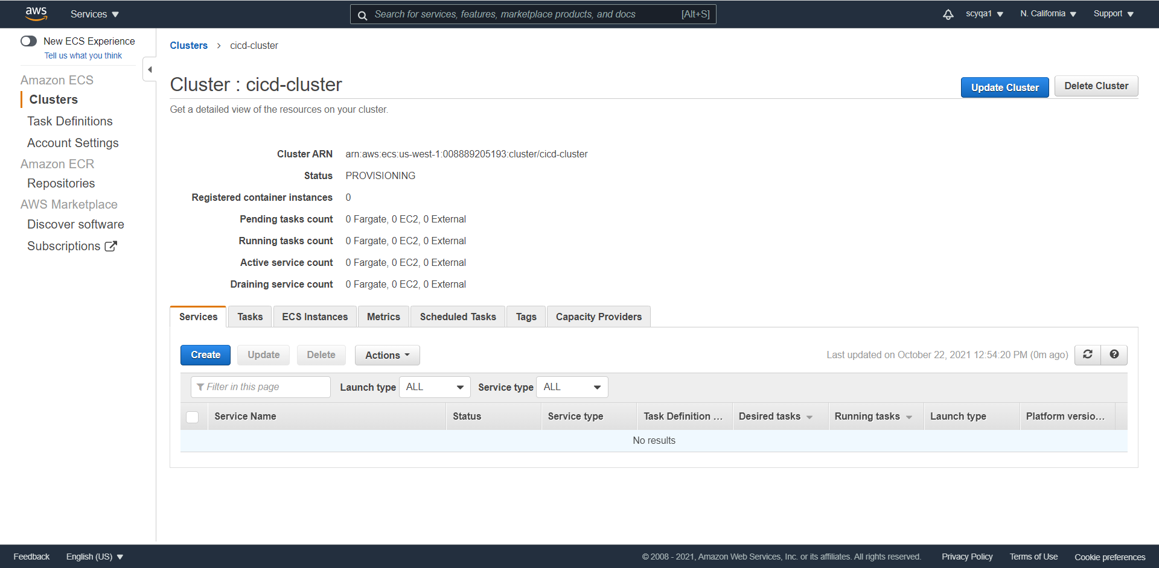

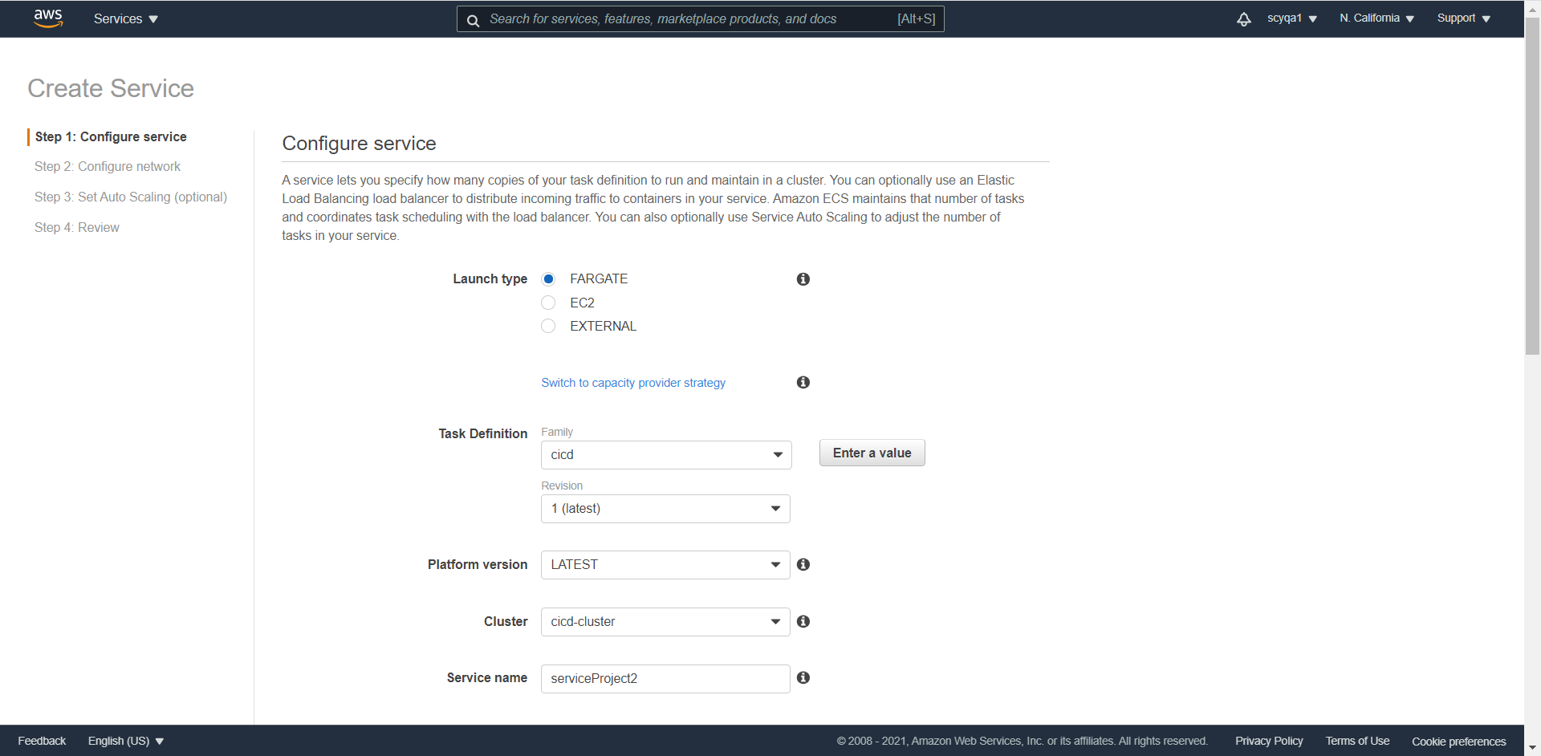

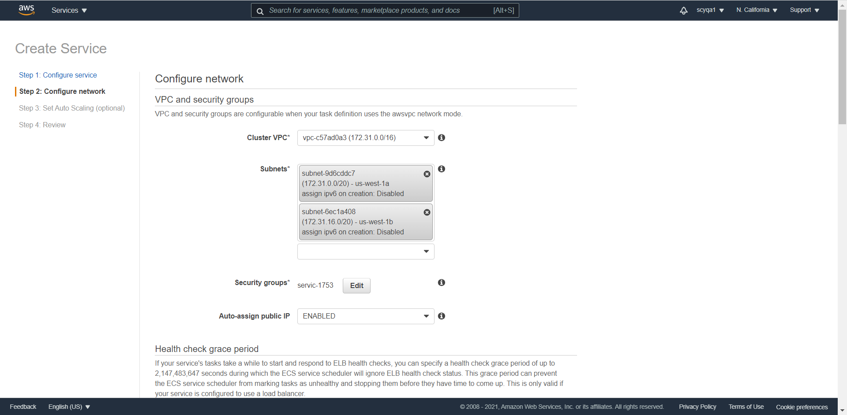

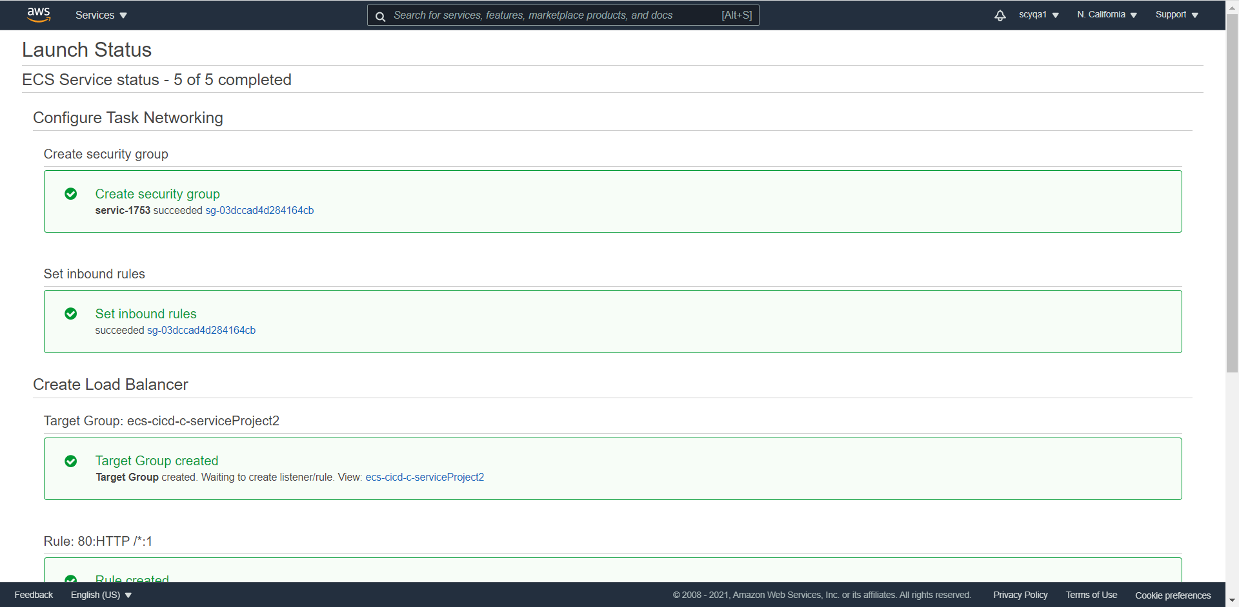

DNS Test



5) [38:00] AWS Code commit: Create a Repo. Set ssh connectivity in your local machine. Push your code into the newly created repo

Create a repo

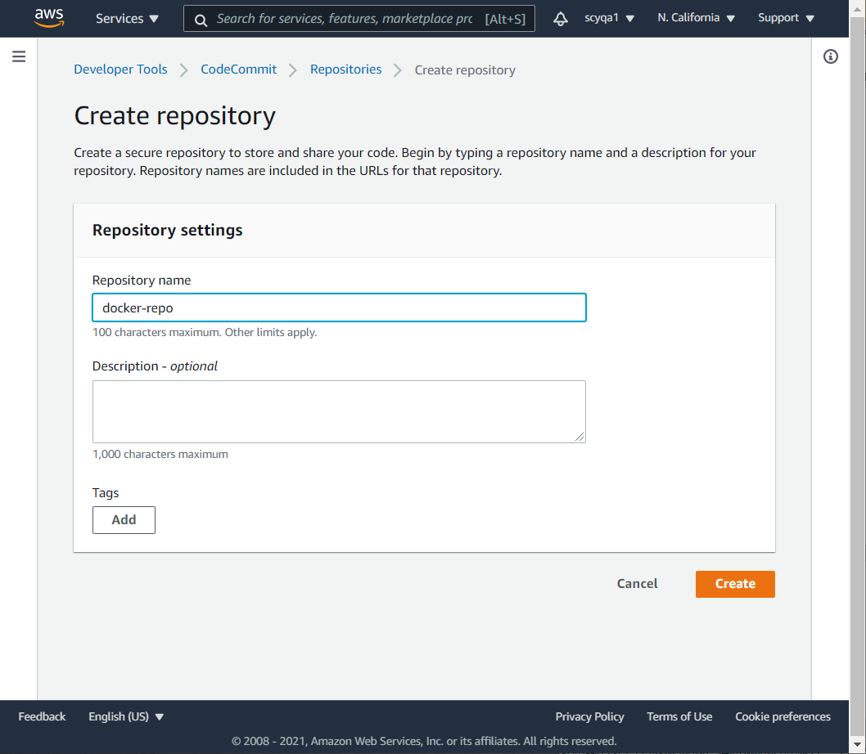

Install git



Generate HTTPS Git credentials for AWS CodeCommit

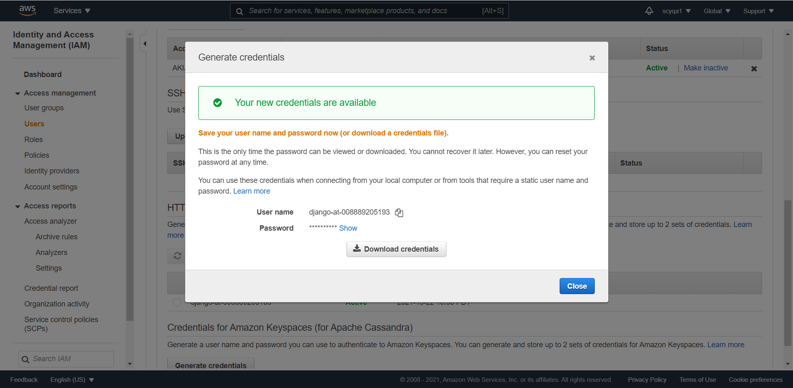

Clone

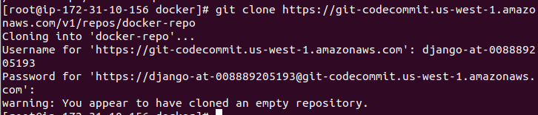

Generate SSH key

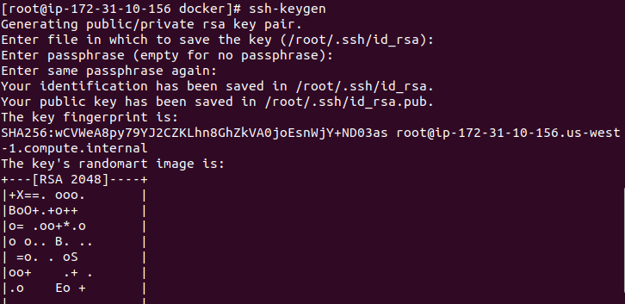

Then upload ssh key

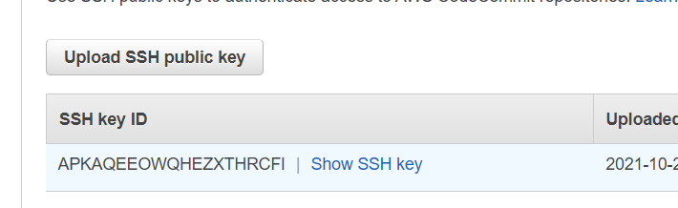

Configure

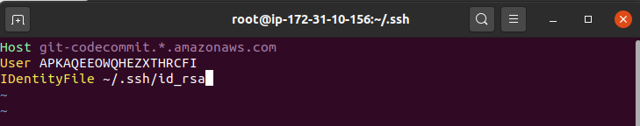

Git operations to push

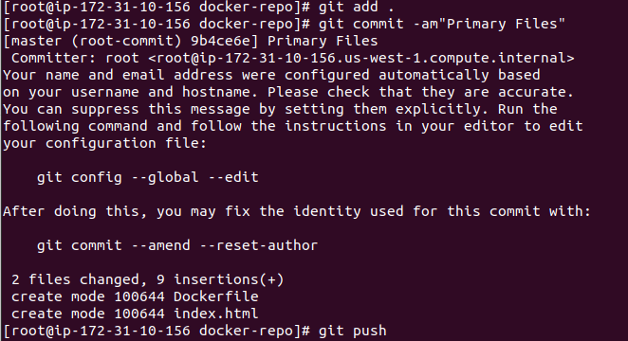

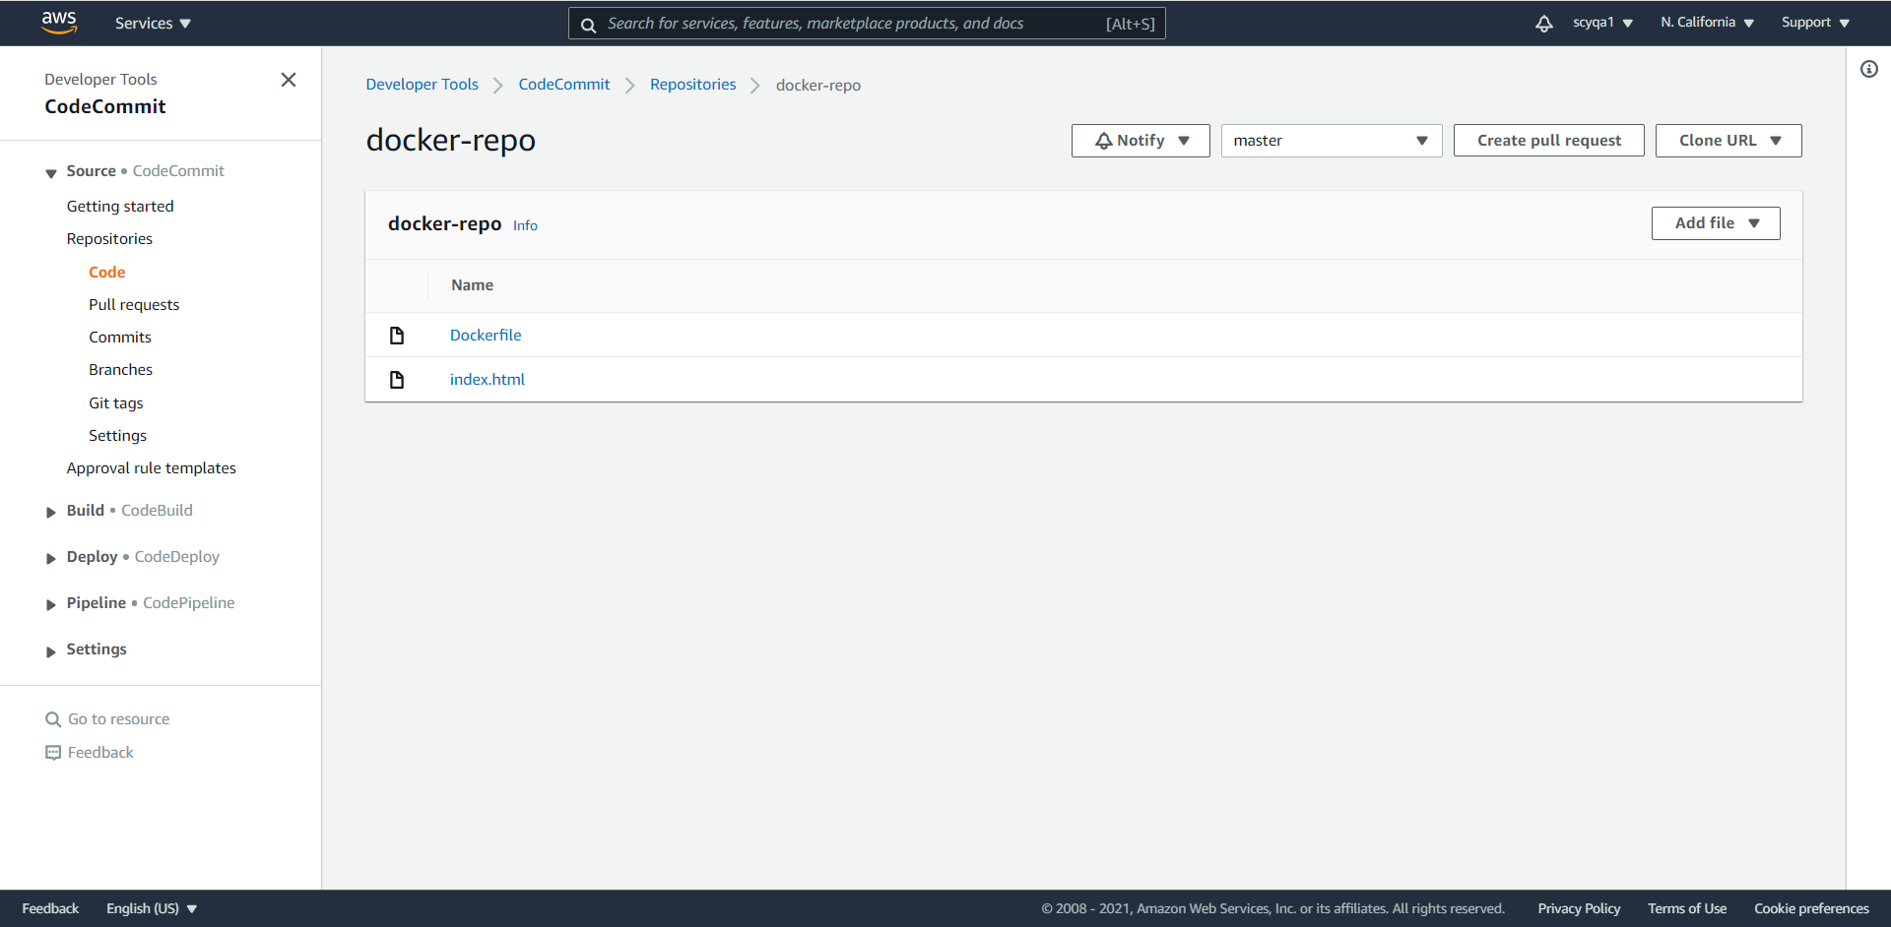

6) [54:00] AWS Code Build: Create a Code build Project. Select an Artifact for output. Build your Docker image & push to AWS ECR

Create build project

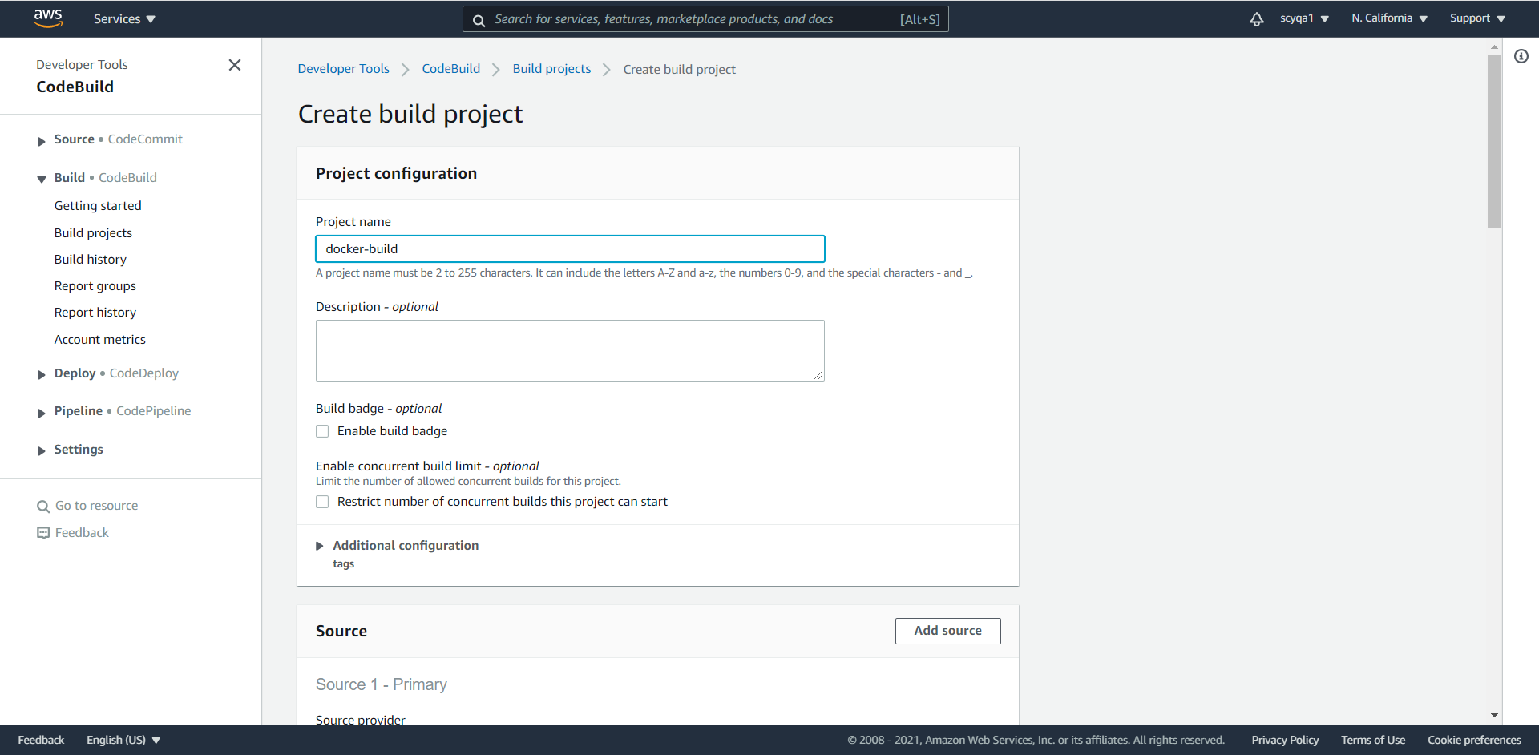

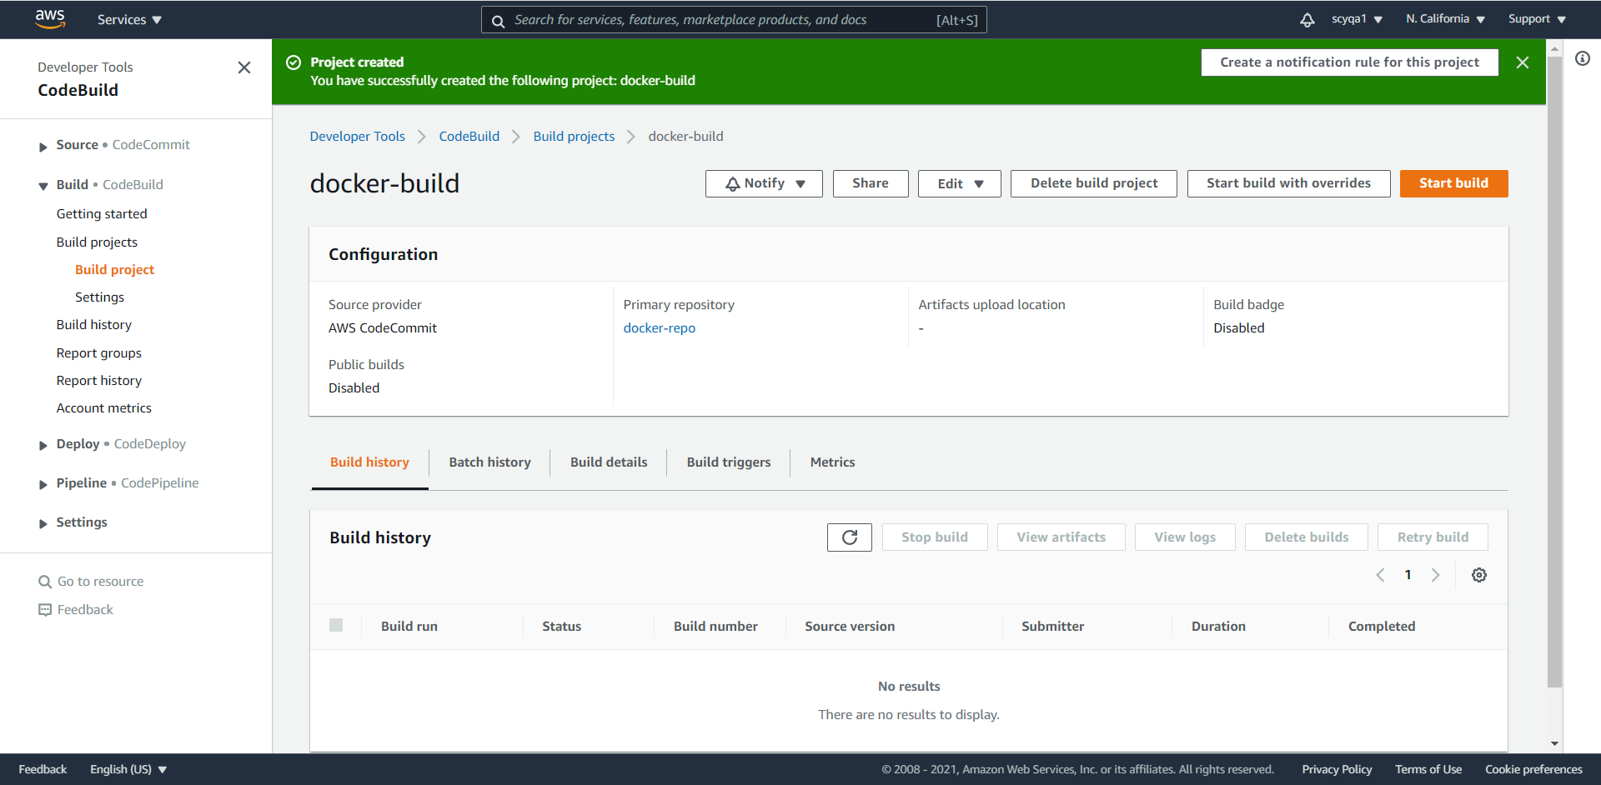

Configure

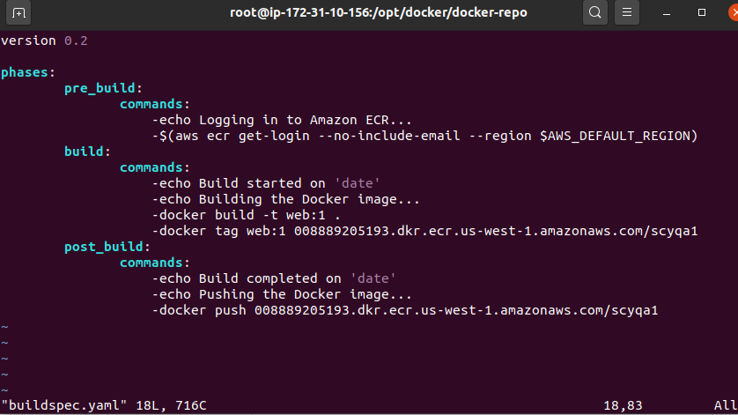

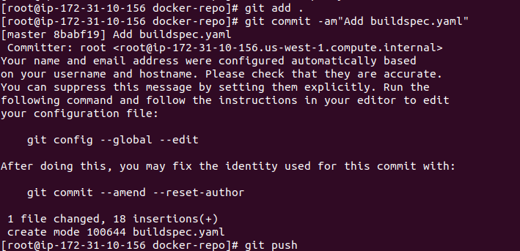

Start build

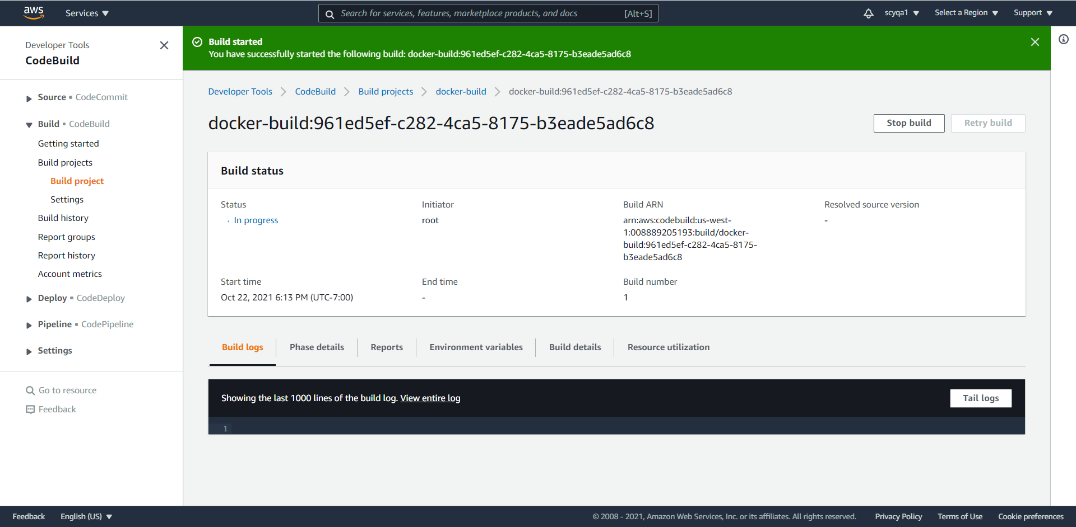

Add policy to roles

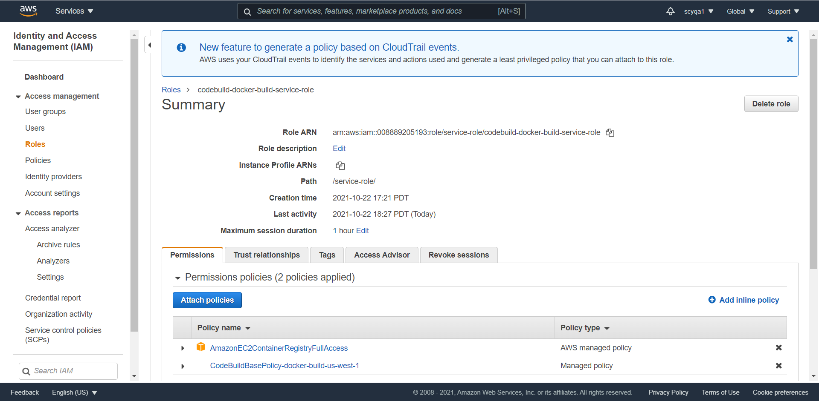

Success

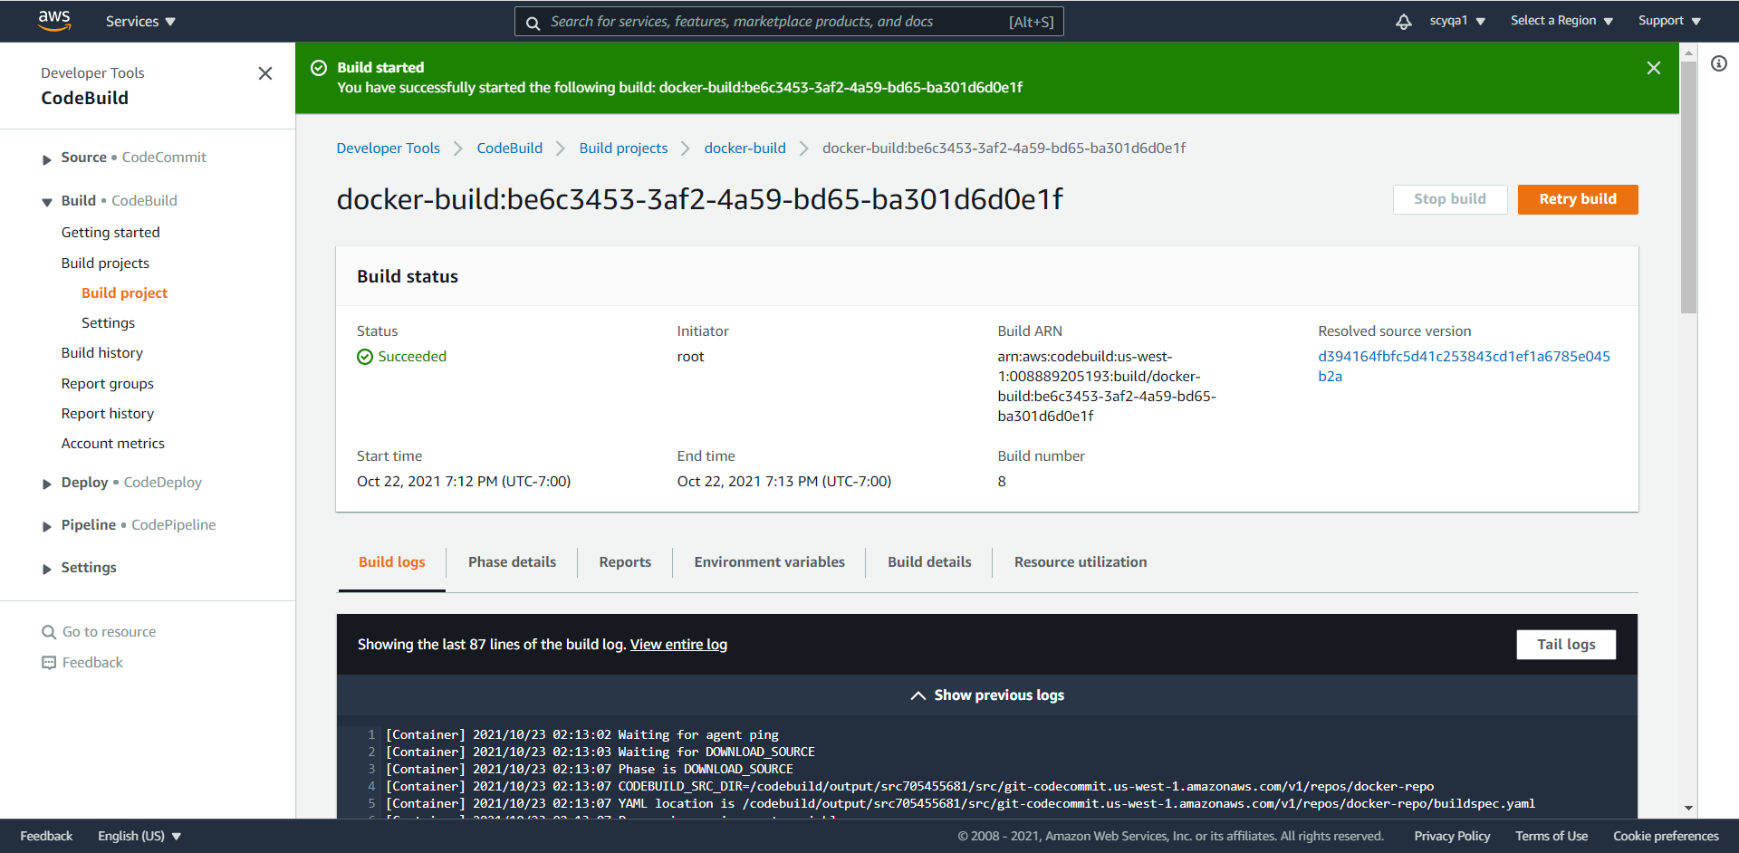

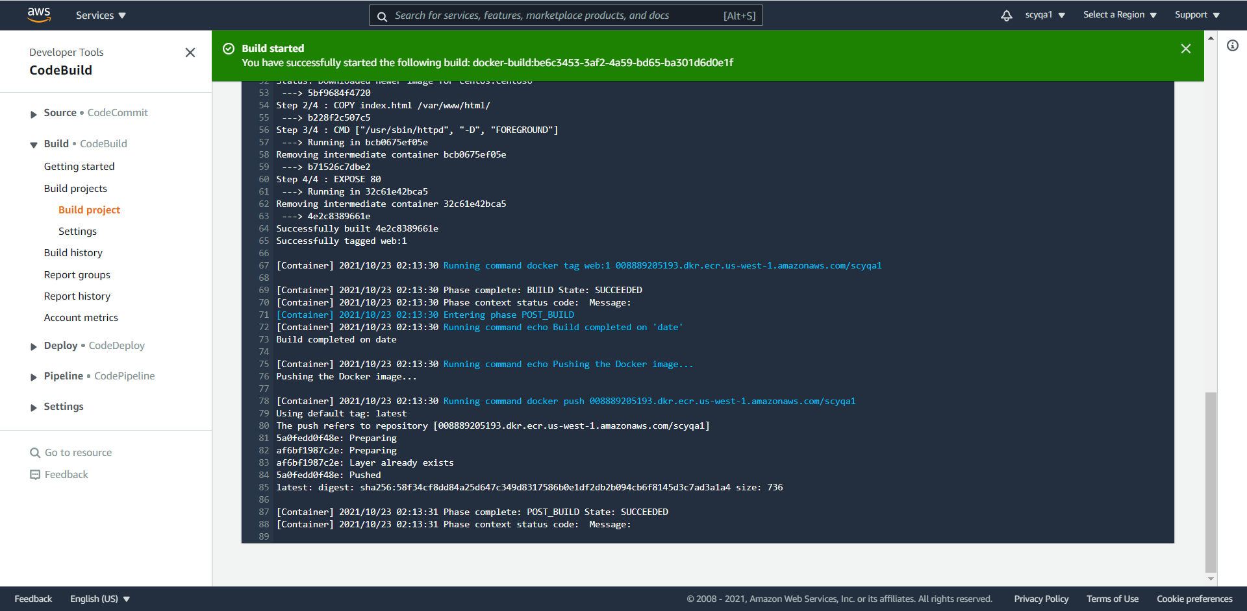

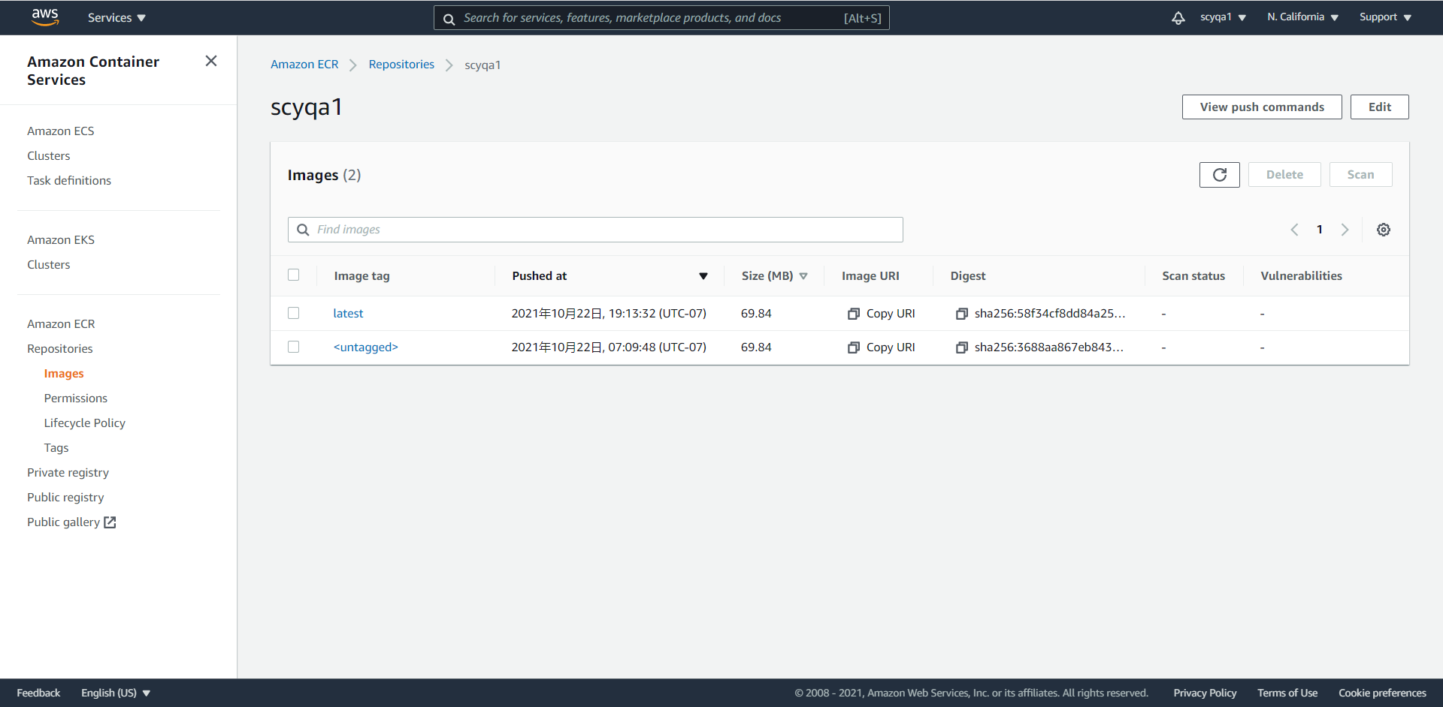

7) [1:06:55] AWS Code Pipeline (the manual one is optional and you can skip it but not harm to try, automated way starts at [1:10:05]): Create a pipeline Project. Select you Code commit repo as an input repo from step 5. Select Code build project from Step 6. Select Code Deploy for ECS. Select your cluster and Service name from step 3. Crete the Code pipeline

Create new revision of task definitions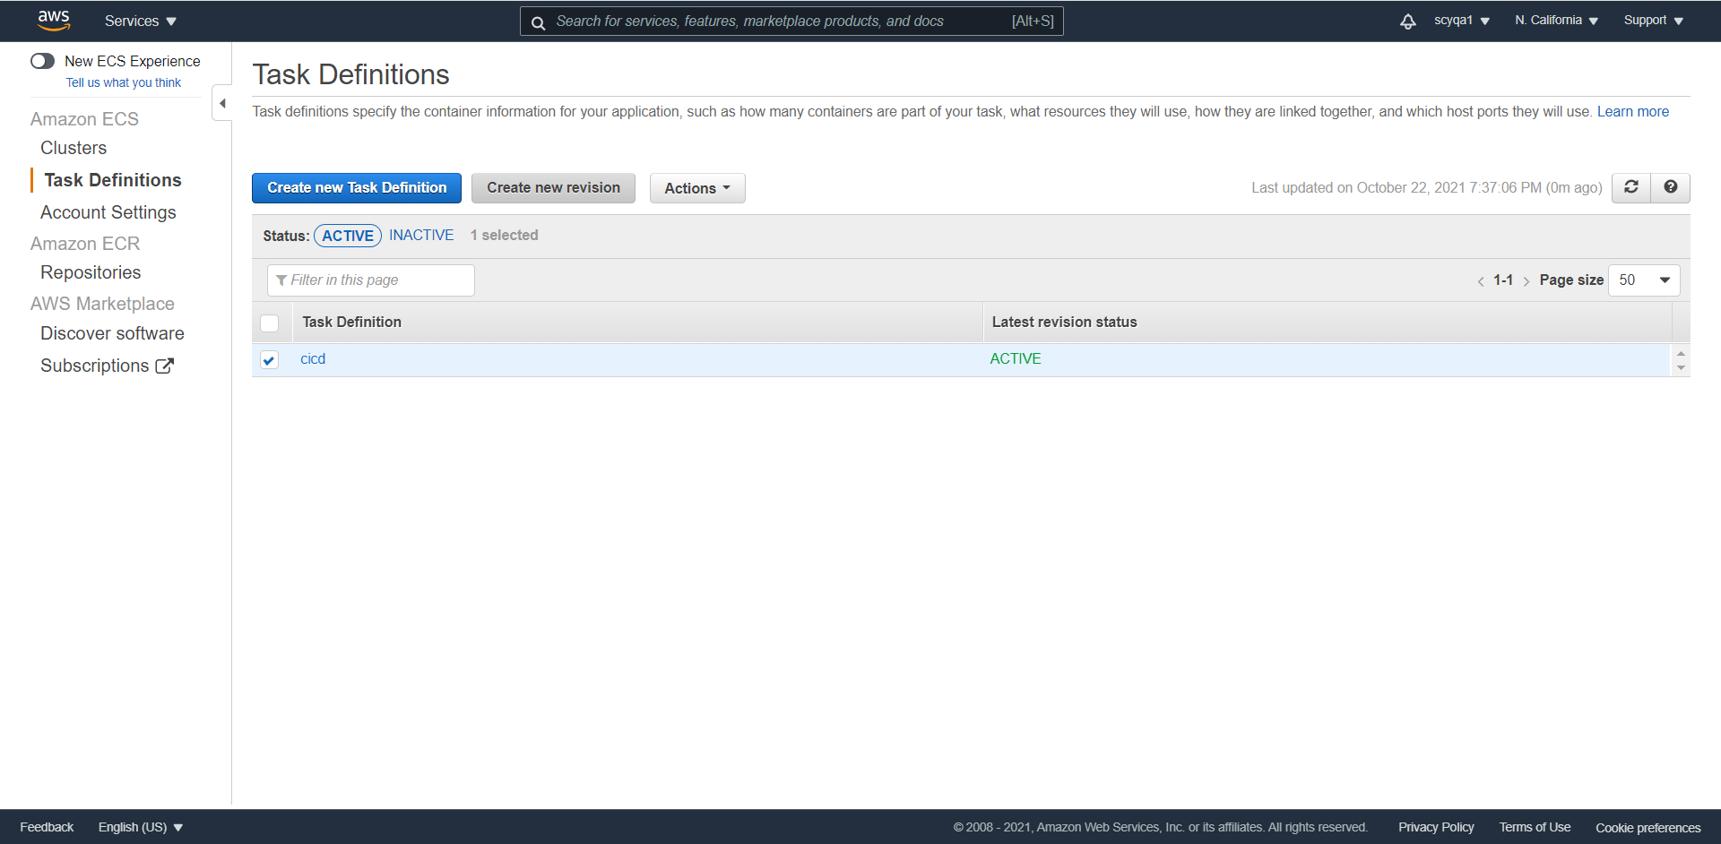

Update container

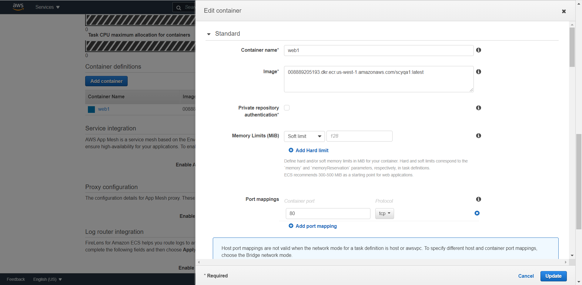

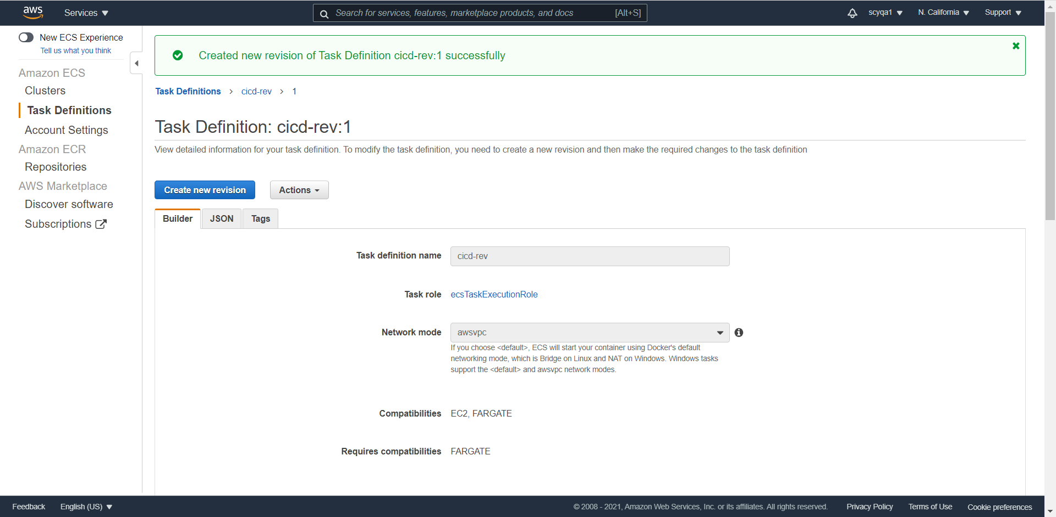

Update service

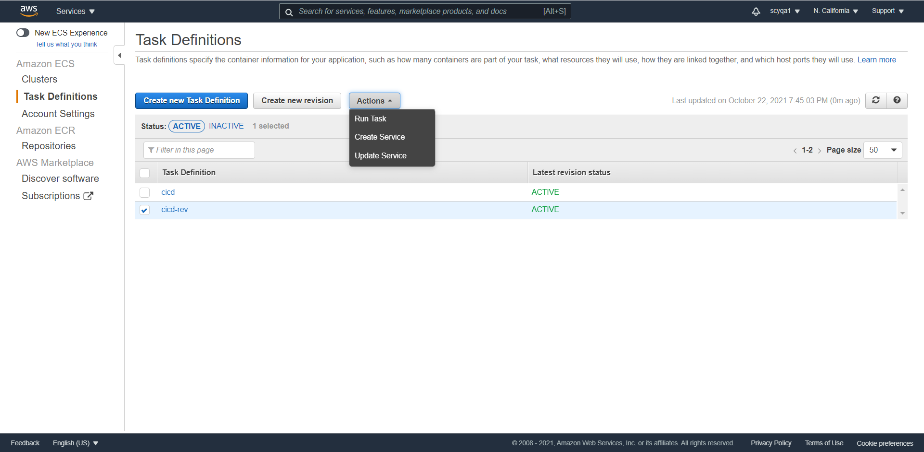

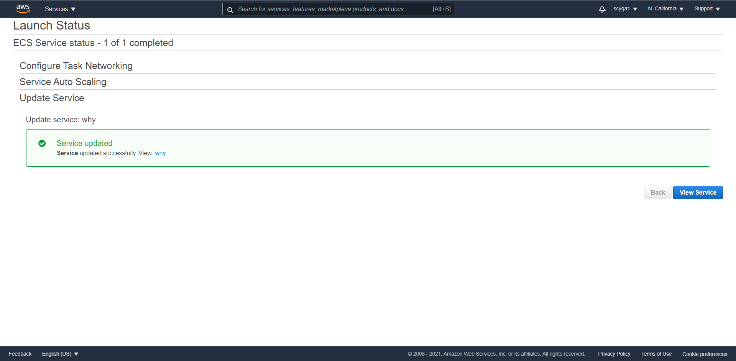

Create pipeline

Choose pipeline settings

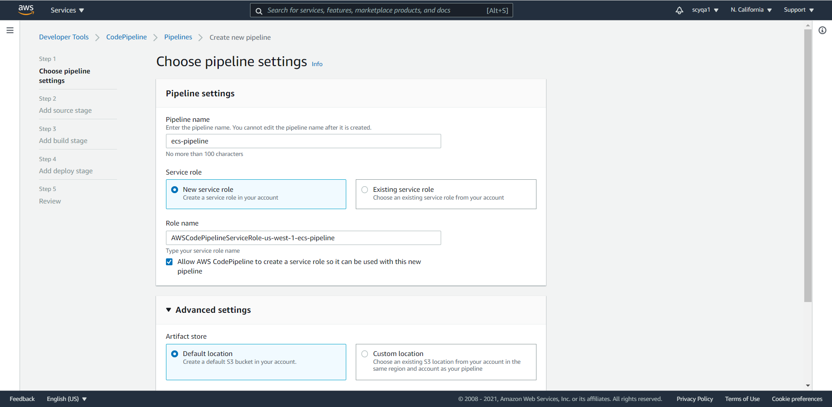

Add source stage

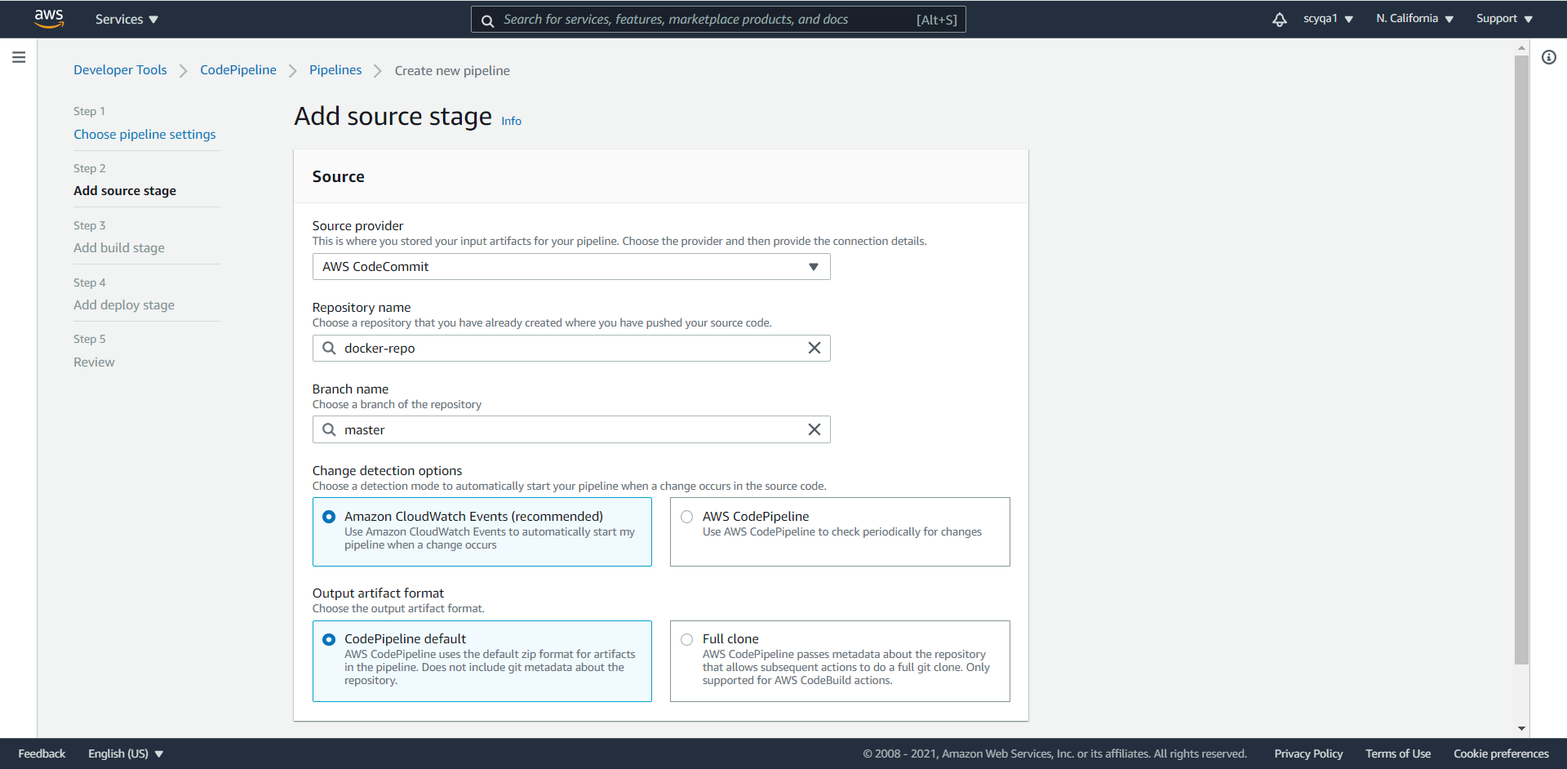

Add build stage

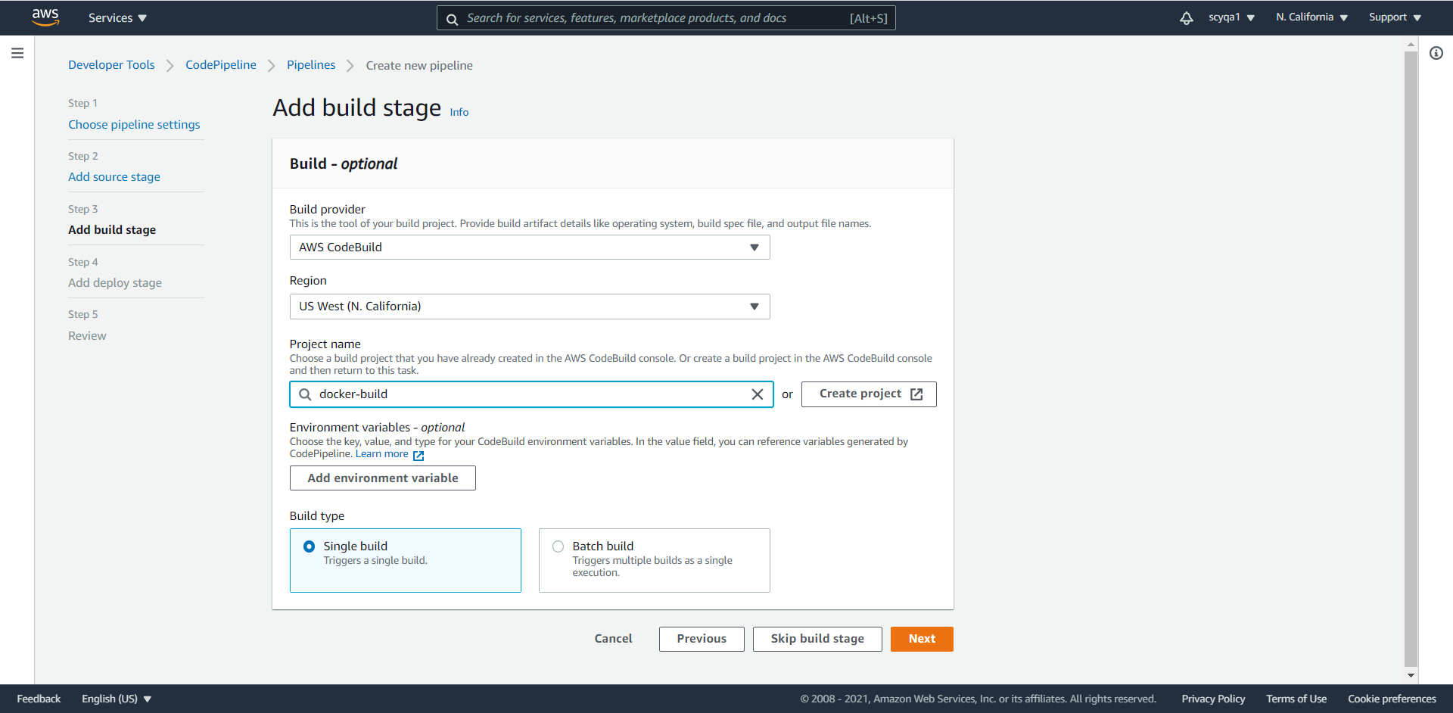

Add deploy stage

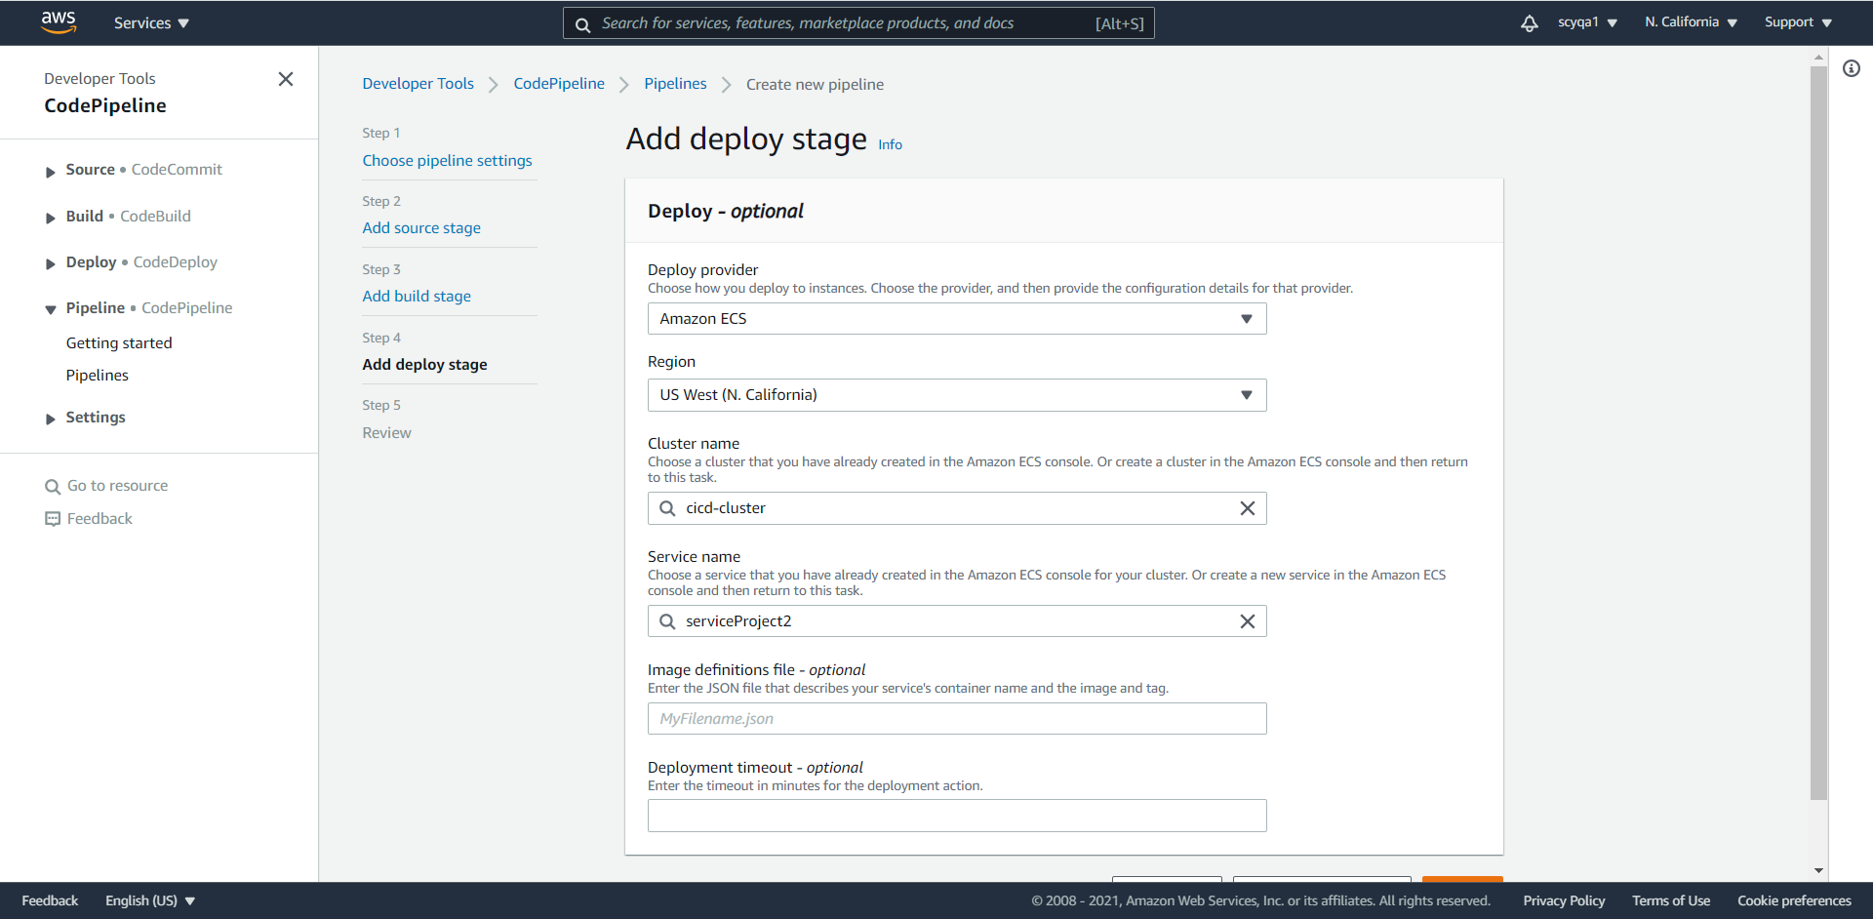

8) [1:19:45] Error & Resolution: In the above pipeline, first 2 steps will run successfully. Step 3 deploy will give you an error. For this, you need to Create one “imagedefinitions.json” file and push it to the code commit. The pipeline will run again and you will again get an error on step 3

Roles attach policy

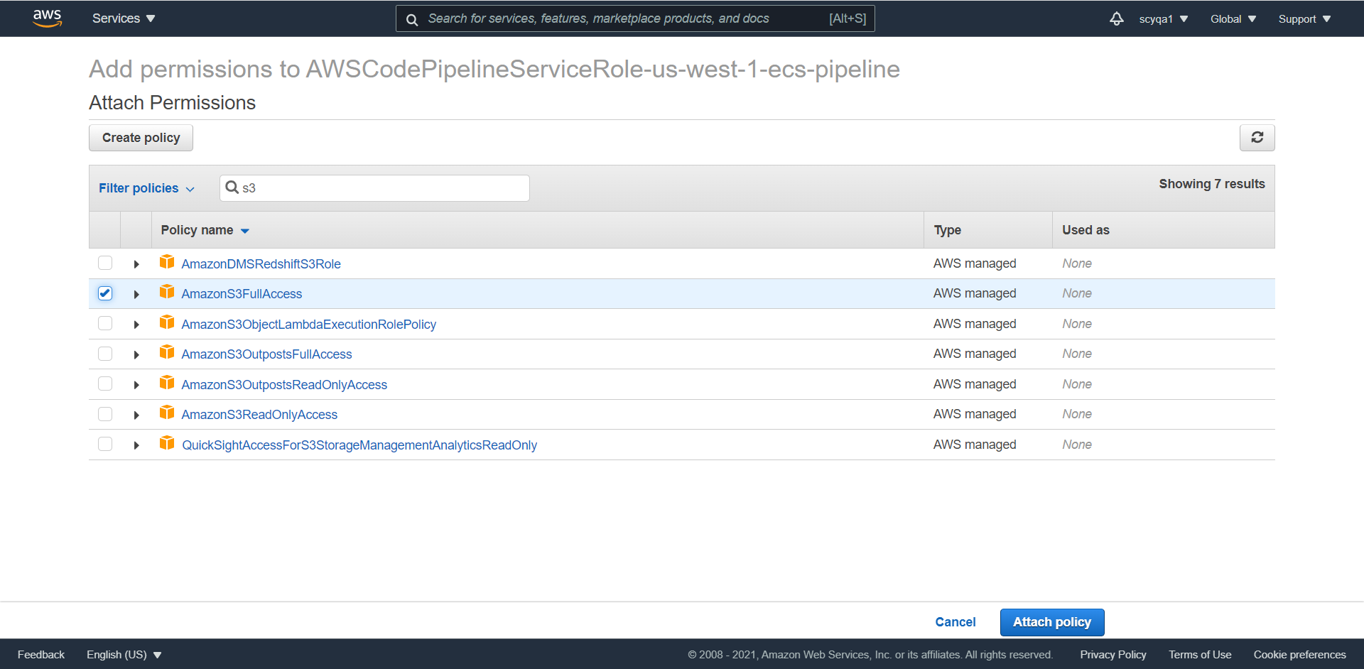

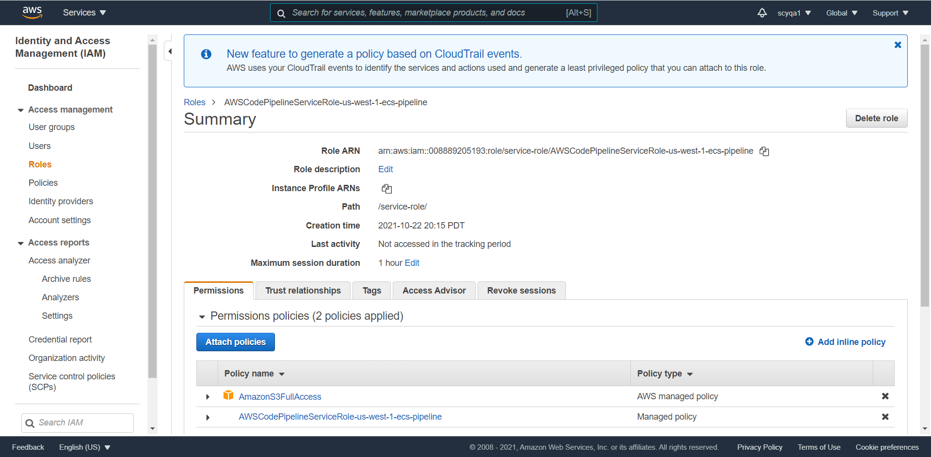

Edit: Deploy

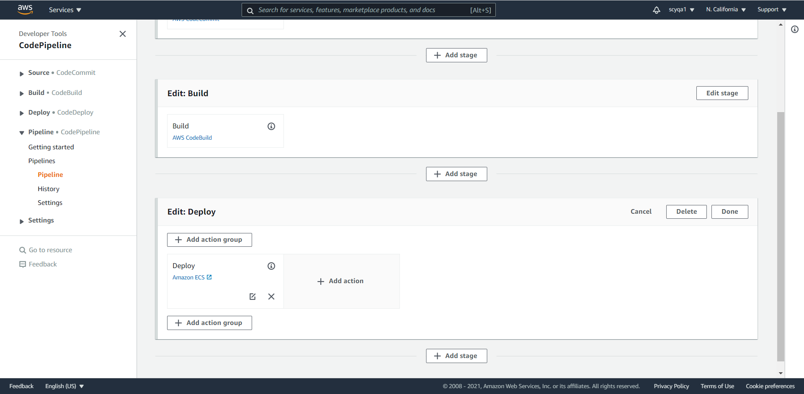

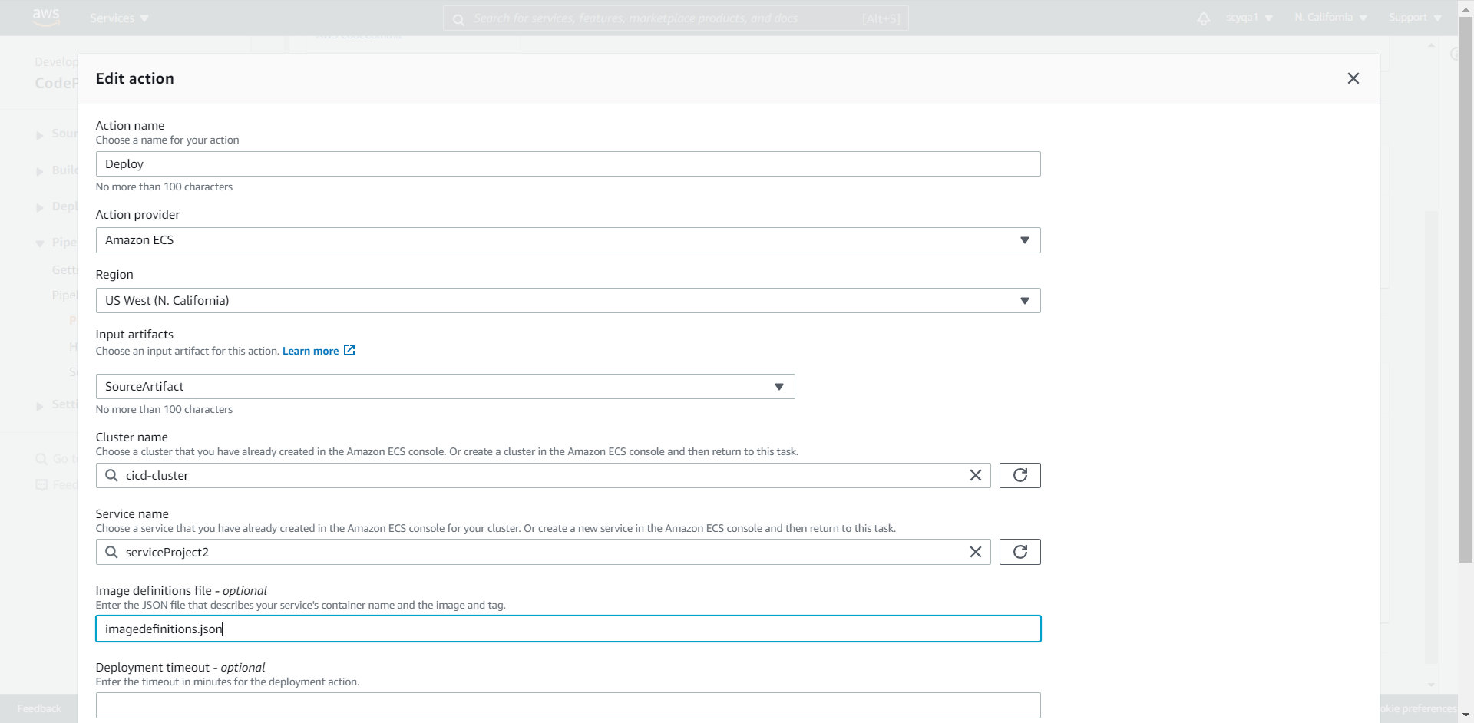

Imagedefinitions.json

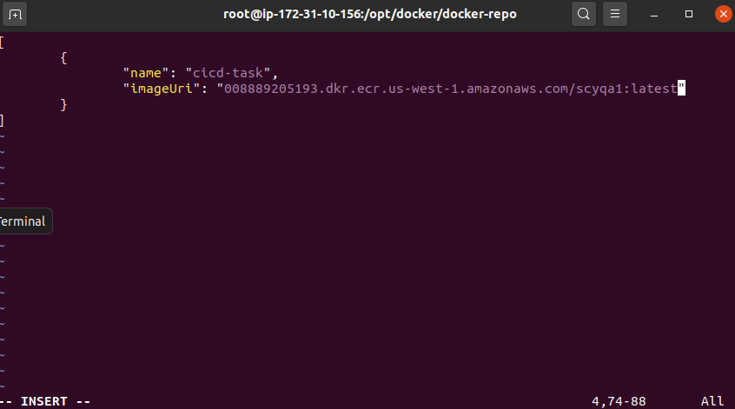

Push

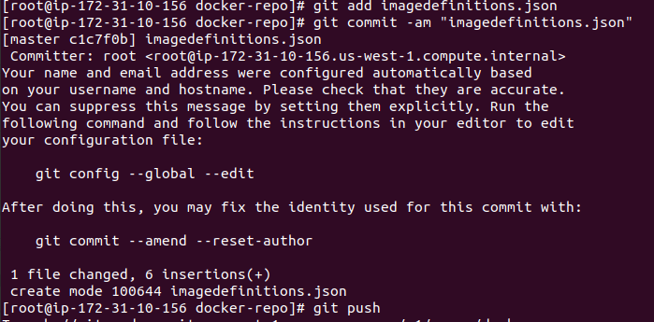

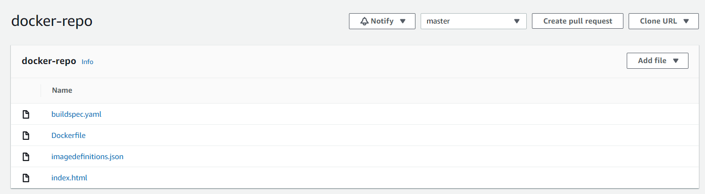

9) Modify Input Artifacts Settings for Stage: Change the input.

Artifacts

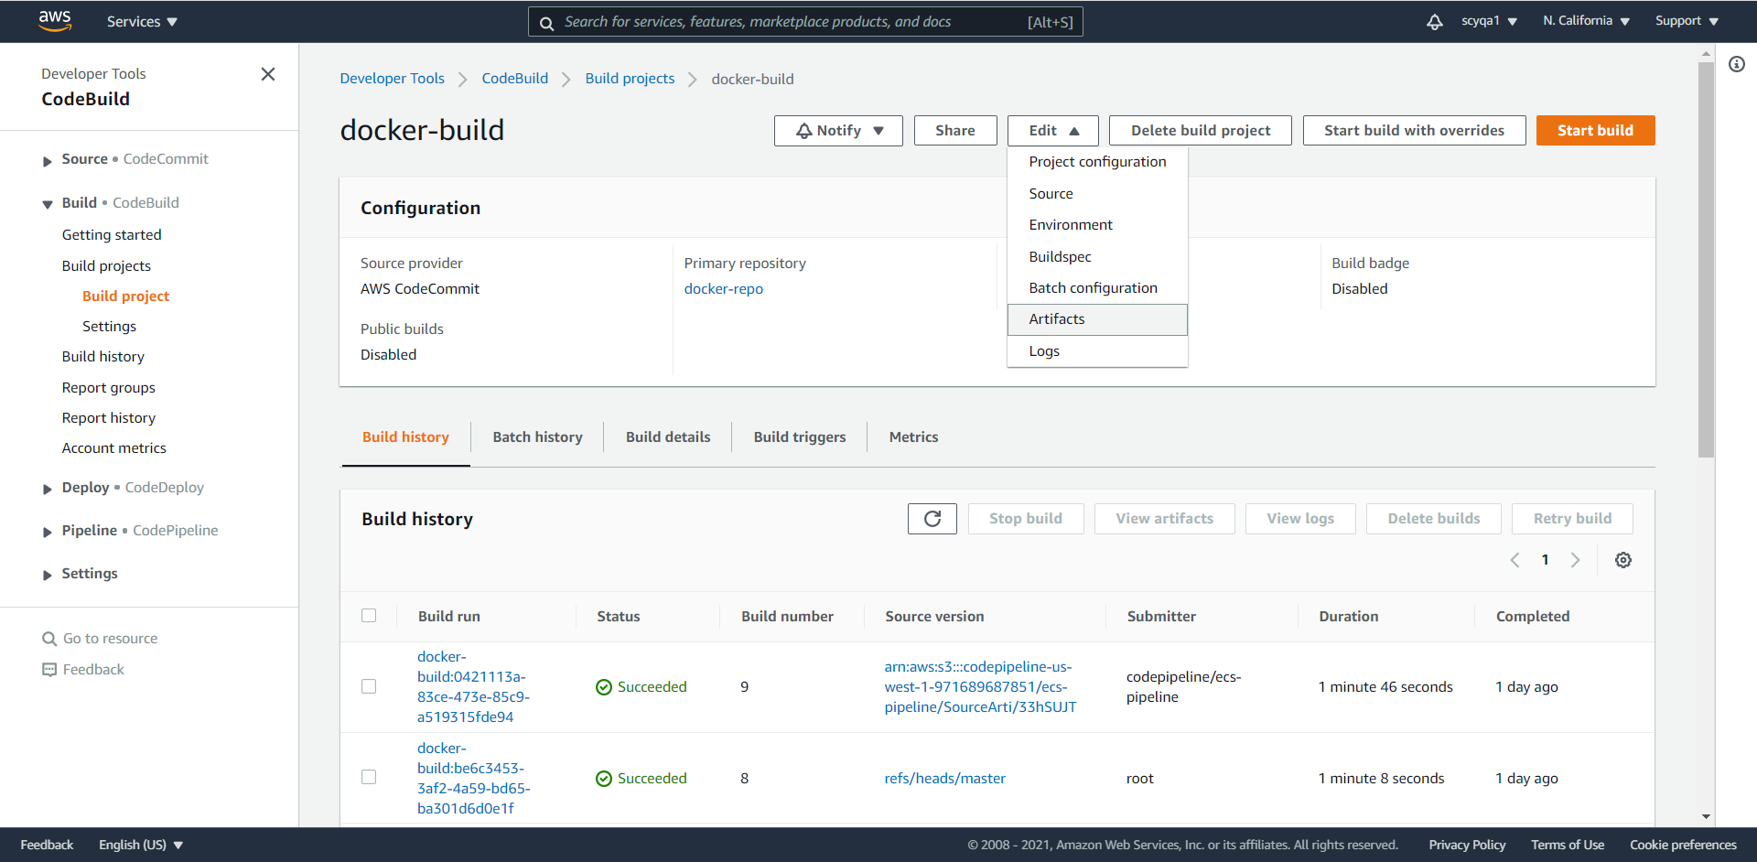

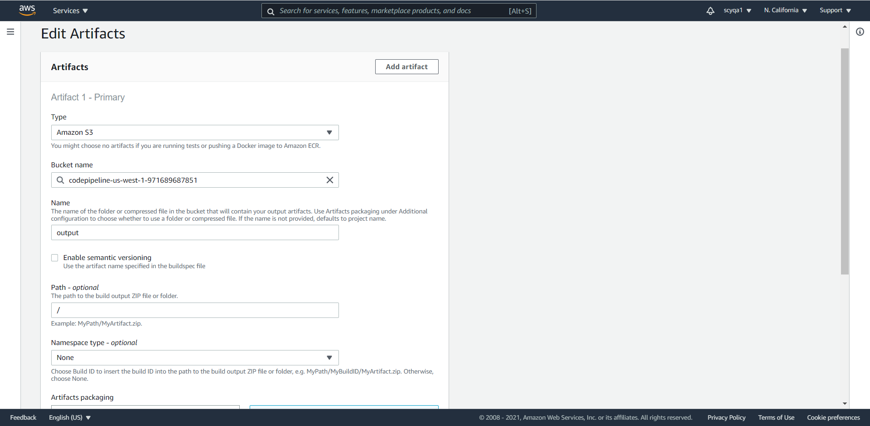

10) Final Deployment Test and Validation: Push the new version of code in a code commit. It will automatically deploy the new task with the new version. At last, you can run the DNS ALB on your browser

Success

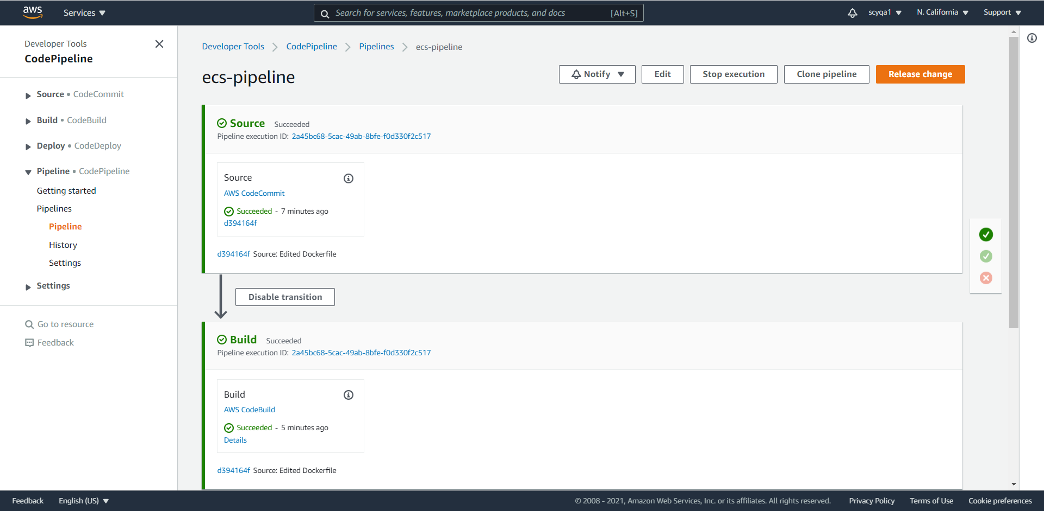



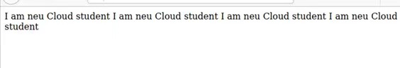

PART II: Design Character Recognition System using AWS Lambda Function [100 points]

1) Docker Read the data from S3 (It is OK if you don’t/can’t use docker but use S3 to store your character image file)

Assigned role with S3 read/write permission and Amazon Rekognition API

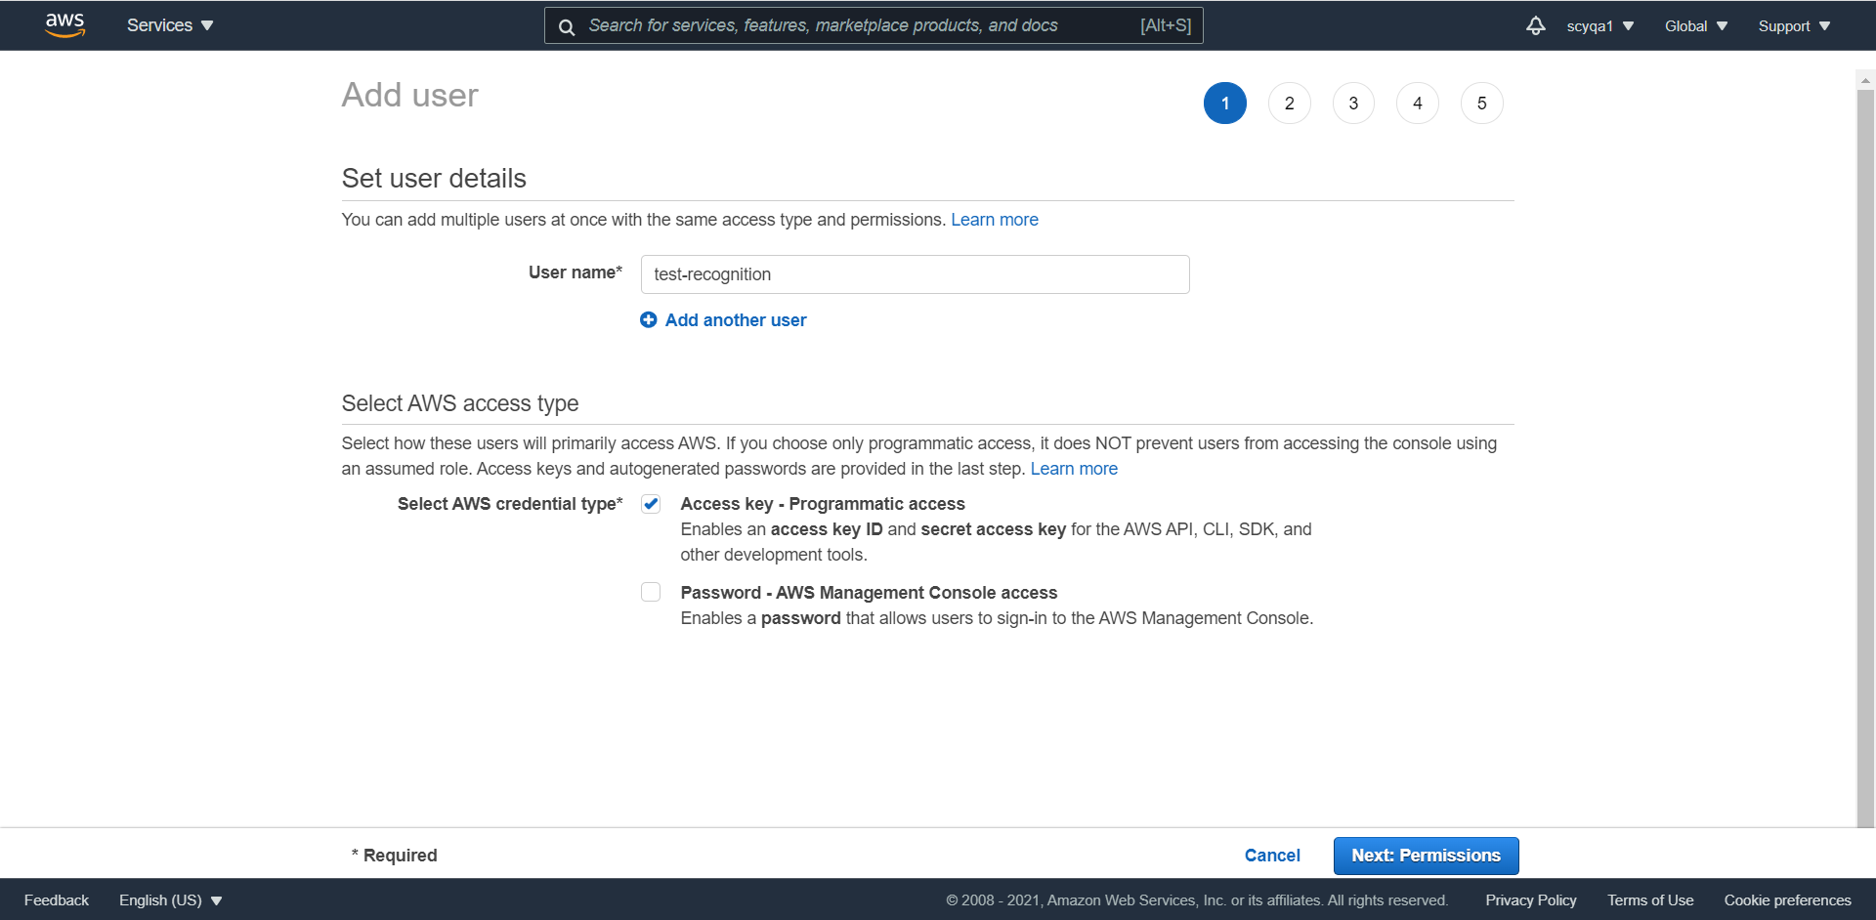

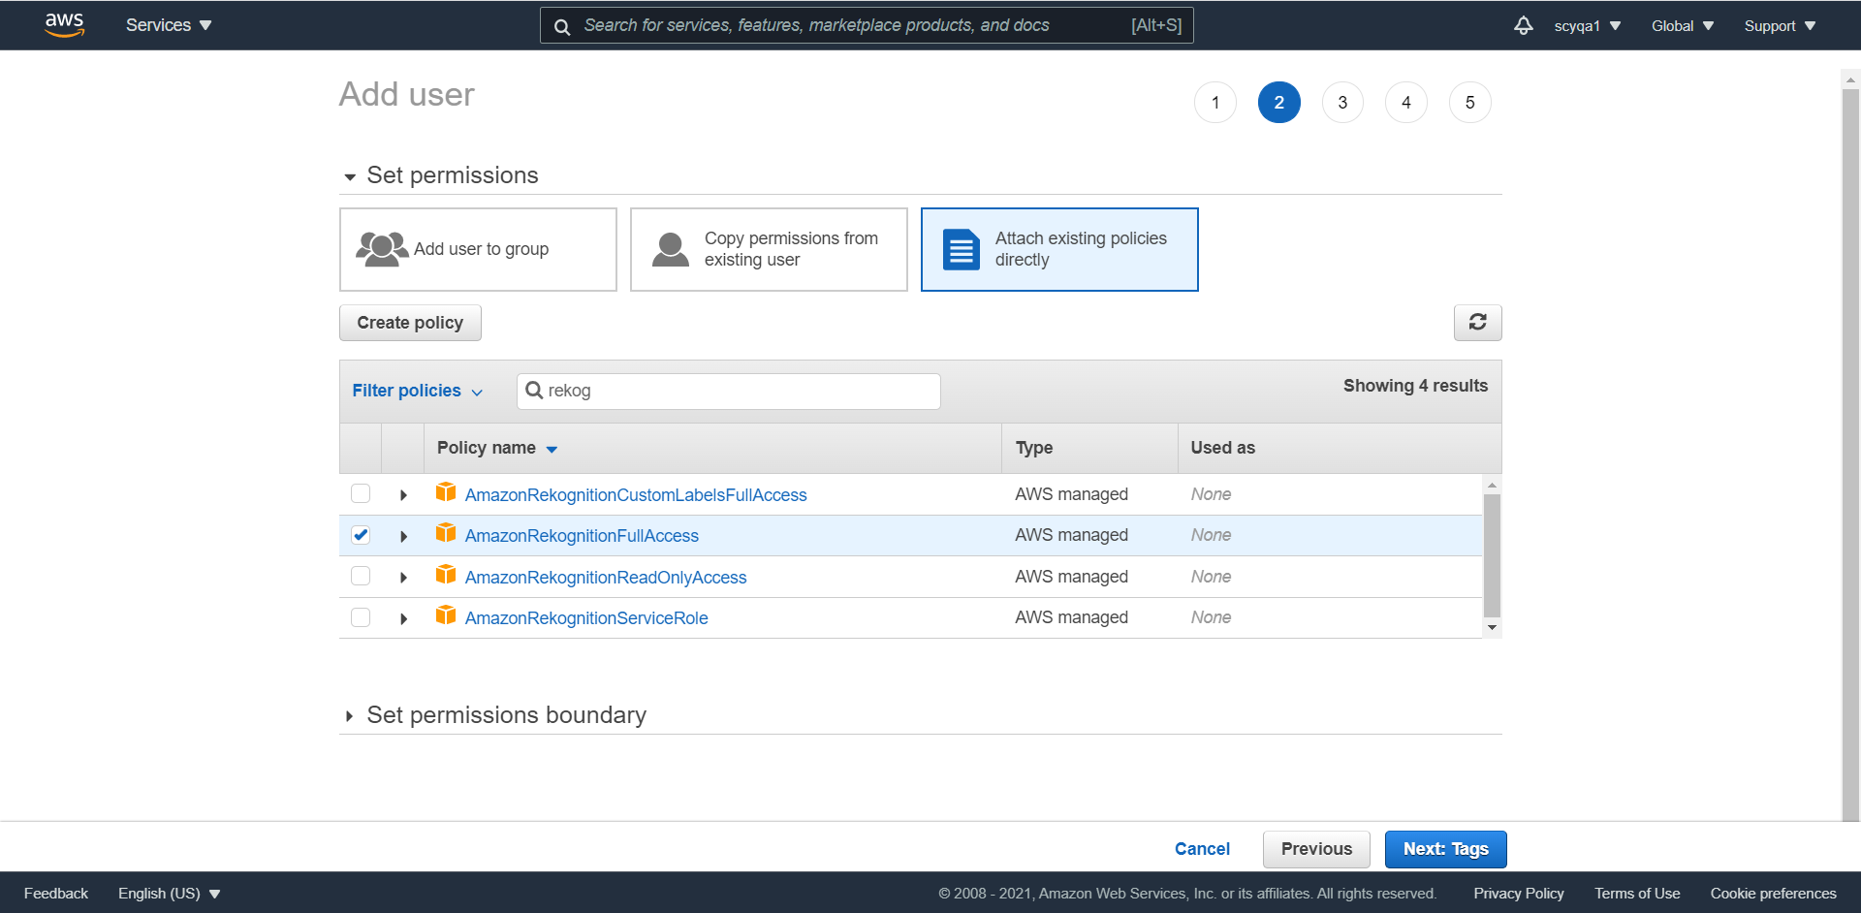

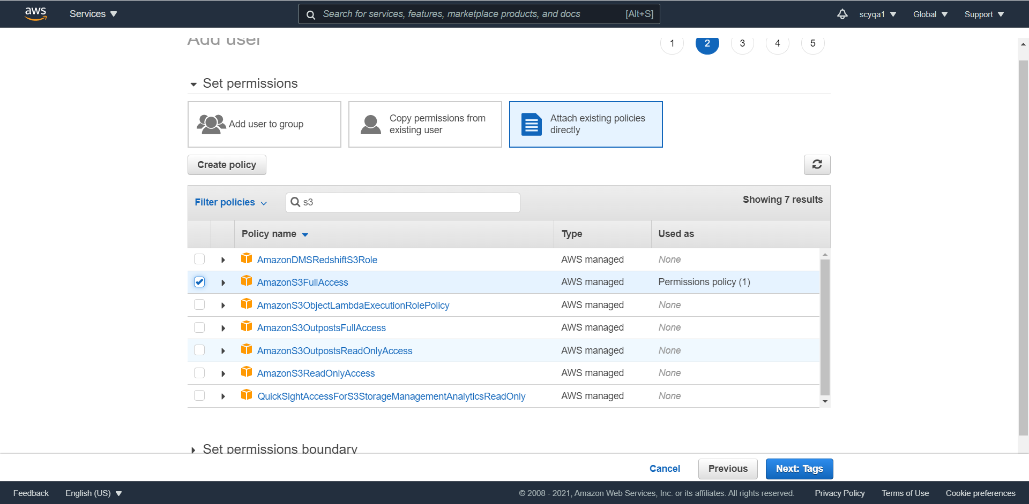

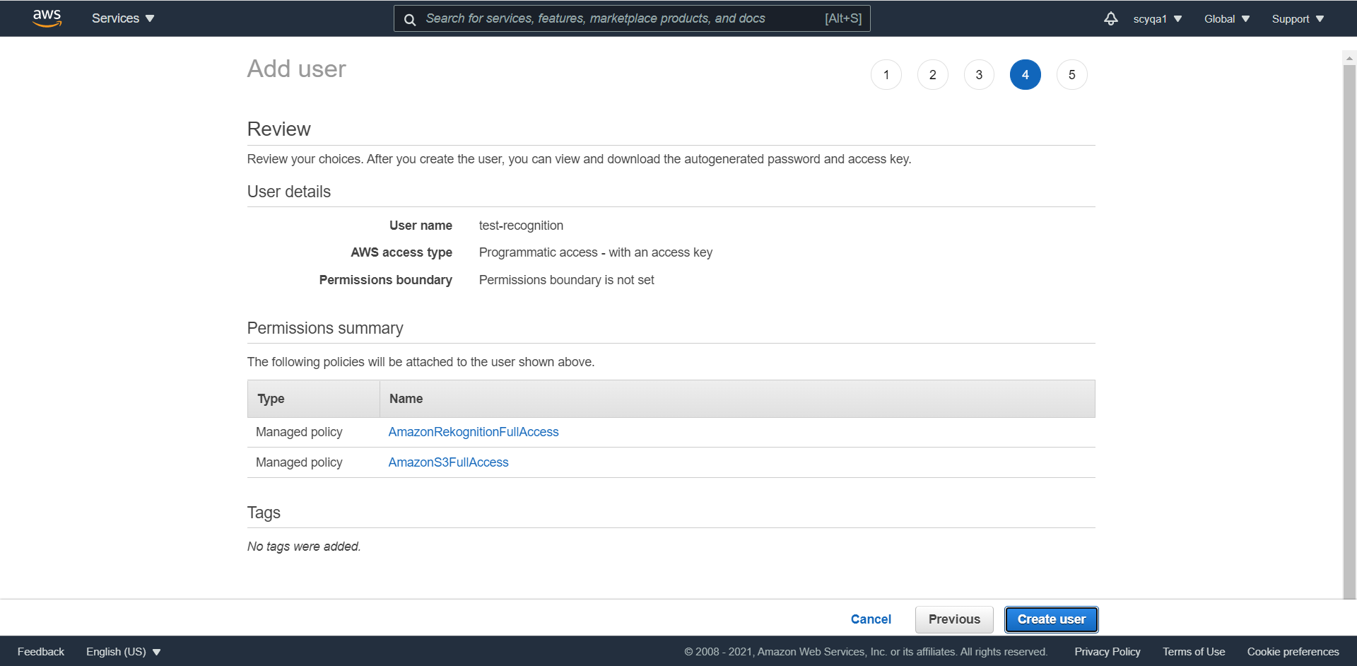

Configure

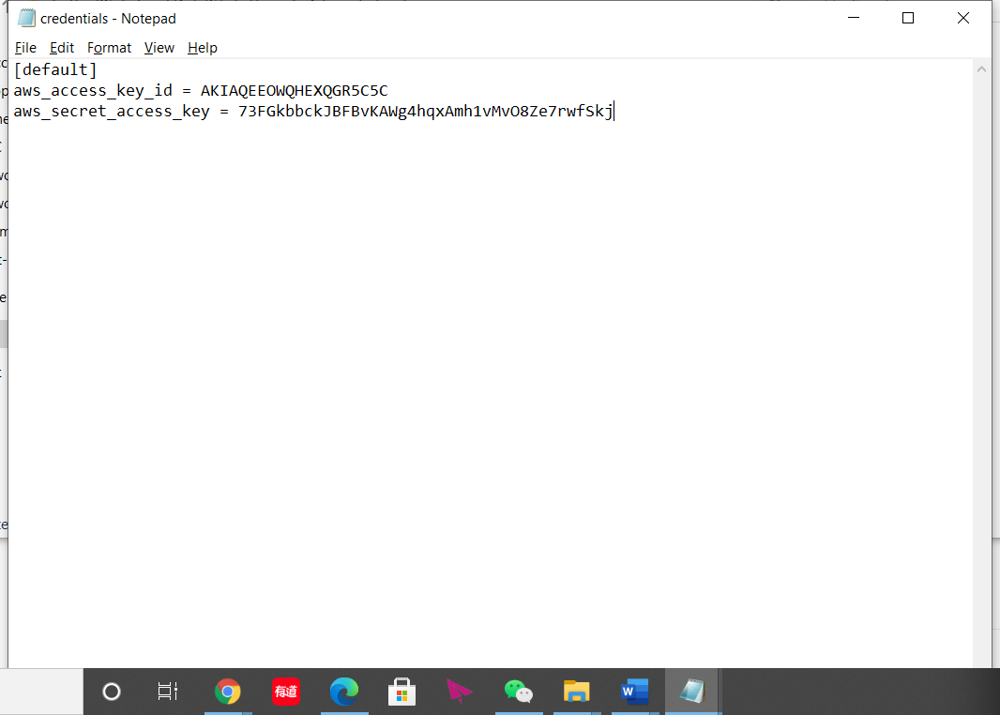

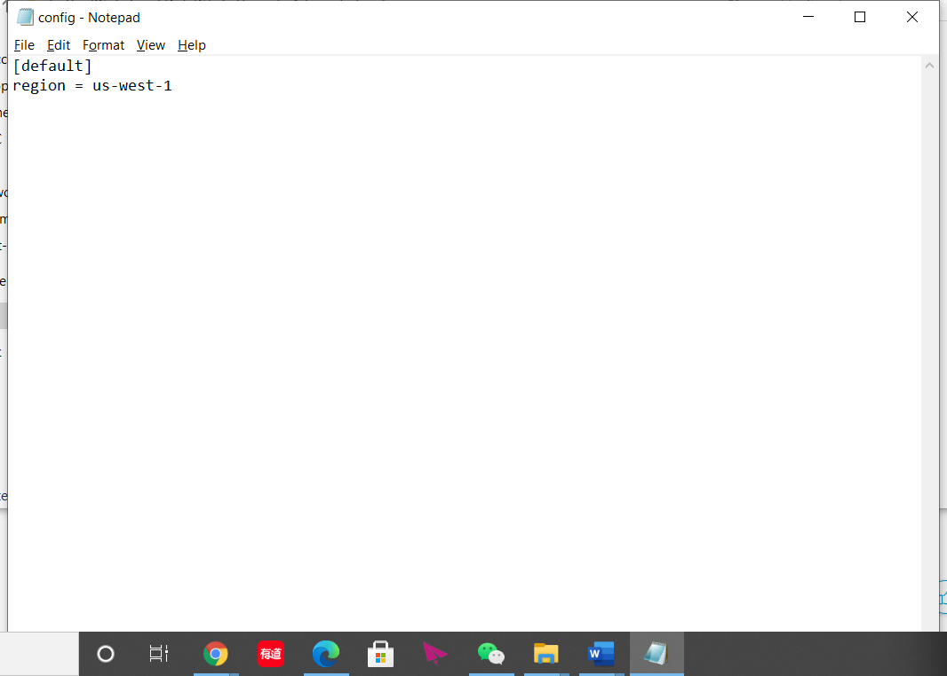

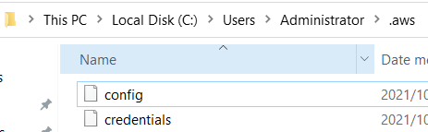

Upload the image that contains text to your S3 bucket.

Used Image:



Upload:



Result:

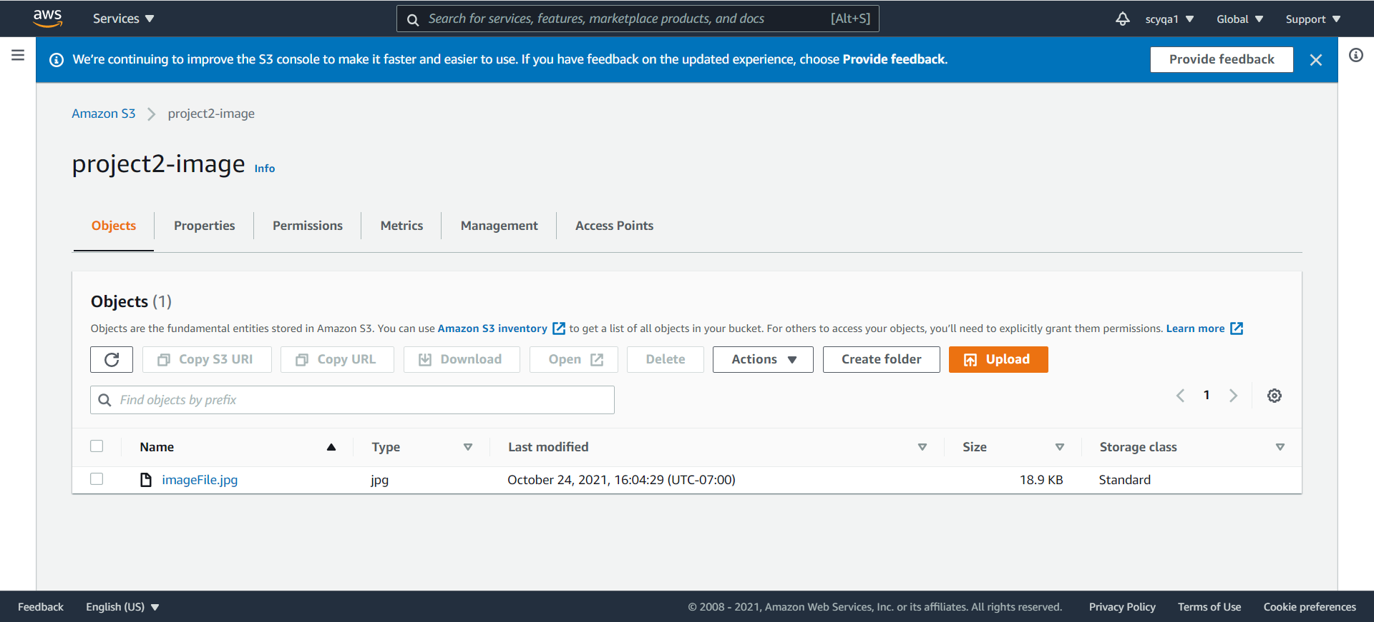

2) Recognize the character present in the text image you placed in the S3 bucket, using AWS API

For this question, I used two methods.

First method: console

Create lambda function

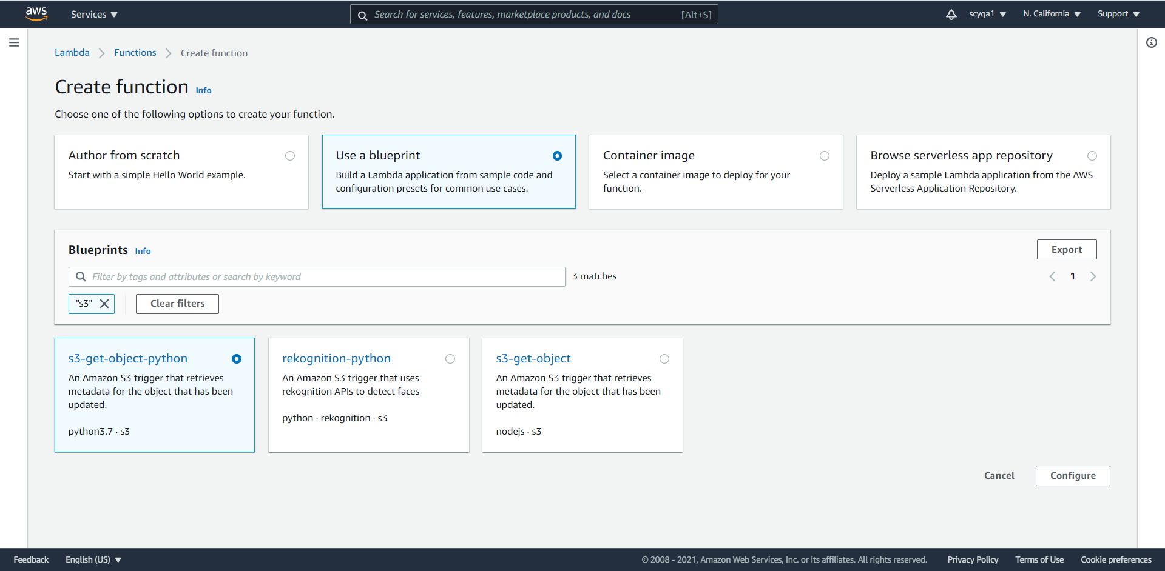

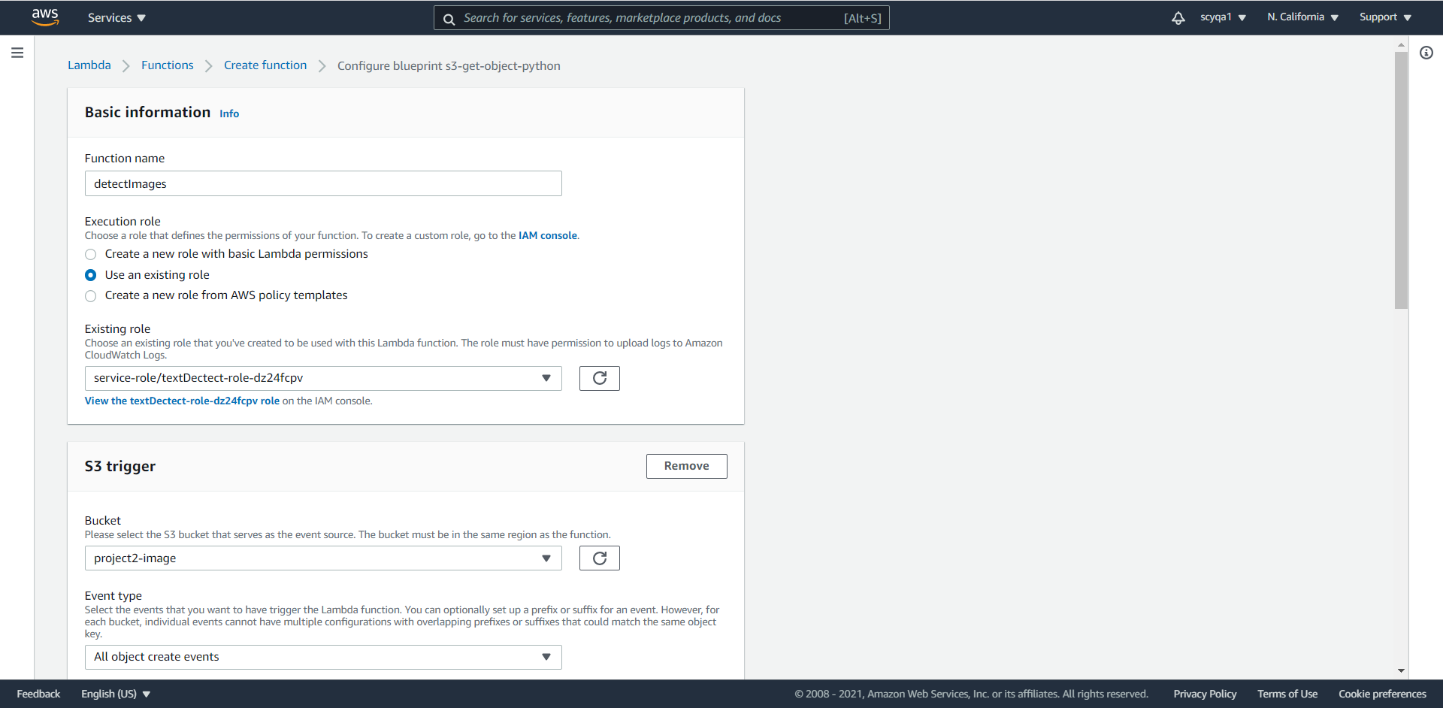

Configure test event

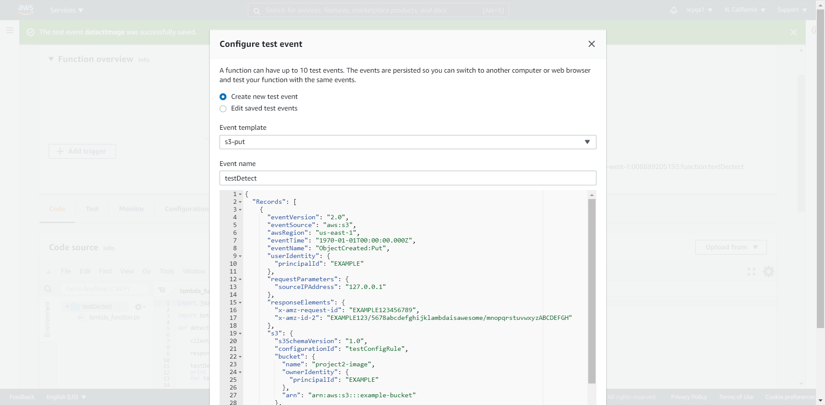

Second method: coding

Install lambda

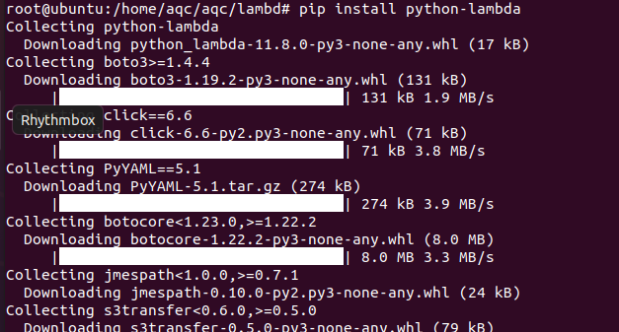

Initialize the project



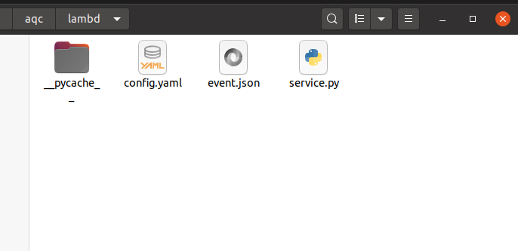

Config.yaml

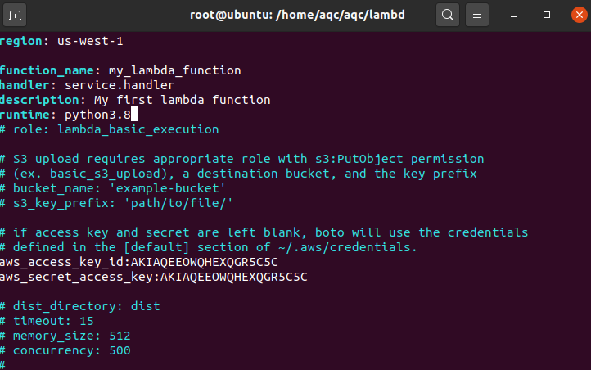

Service.py

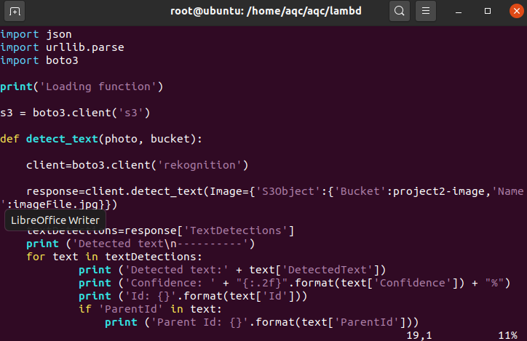

Running result

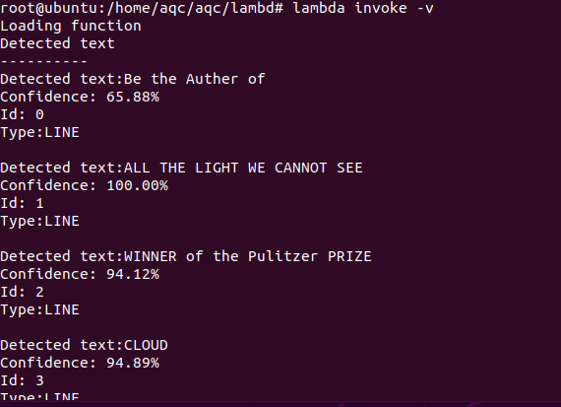

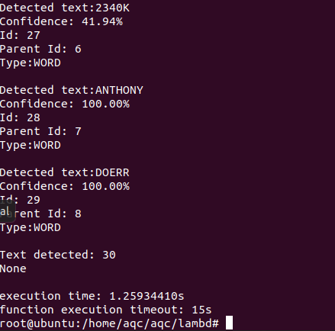

Deploy to website



3) Upload the extracted text from the above step back to S3 bucket. This is your Ouput (Result) text file.

